CABALA MINERALIS

The First Book
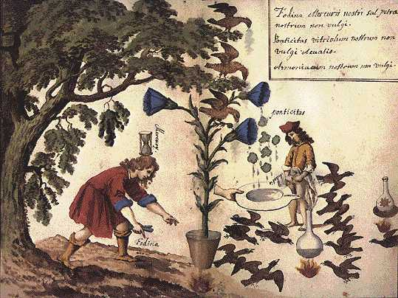
The mine of our mercury is our saltpetre not that of the vulgar.
Our sharp bitter vitriol is not that of the vulgar
Our ammoniac is not that of the vulgar
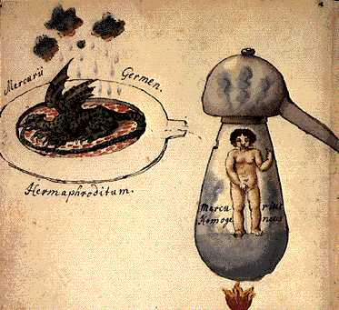
The sprout of Mercury.
The water of life
Nine volatile parts fix one part of mercury.
Homogenitas the sharp living water.
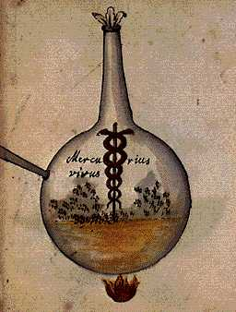
Our mercury.
The living pontic water.
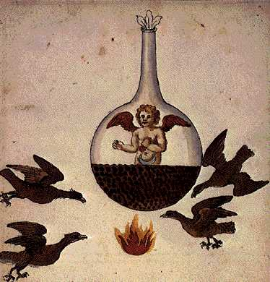
Two to more than three parts of our mercury dissolve one part of the common moon or sun, and they become inseparably one spongeous porous body, which is called our moon or sun, not the common.
The moon through mercury of five eagles.
The Sun through mercury of seven eagles.
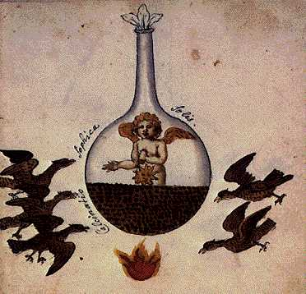
The sophic calcination of the sun.
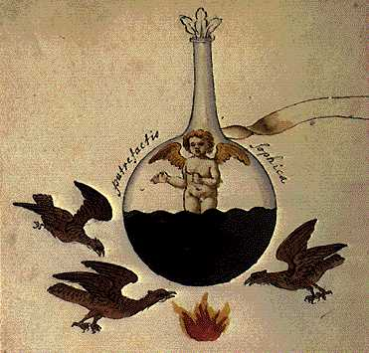
The sophic putrefaction.
Of the calcination of our sun, having been watered with new mercury, two parts in weight, the common sun is made one body, black and not porous.
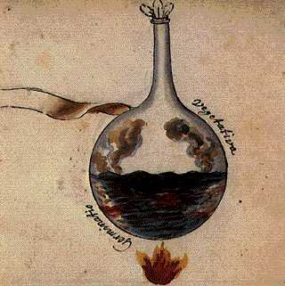
The Germination of vegetation.
The sun having been changed through the black colour becomes green, it is spread out into the vegetation.
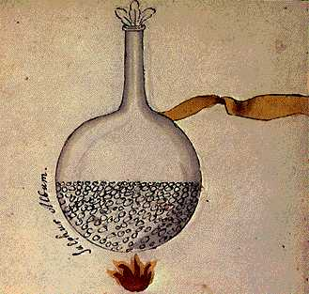
The white sulphur.
Our sun having been changed into a green colour, passes into white sulphur, which is the body animated by the incorruptible soul.
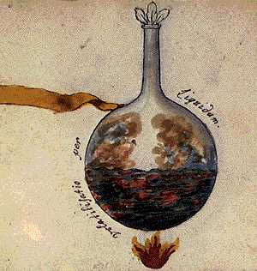
Volatilisation through liquid.
Here our white sun, without any imposition of a hand, nor opening of the flask a second time, is melted, the heat having been continued, with many coloured vapours resembling the tail of a peacock, then our white sun is being volatilised through a liquid.
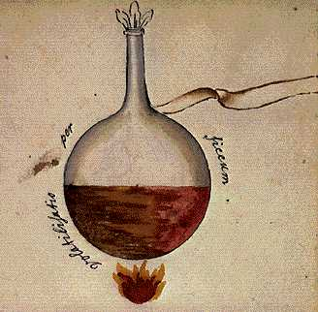
Volatilisation through dryness.
Our volatile sun having been prolonged in heat, now having been made through liquid is dried up and becomes a body shining, as if dawn is breaking, and this is the volatilisation through dryness.
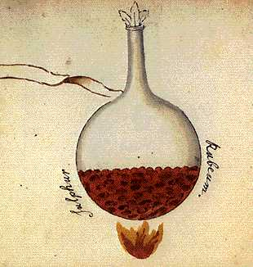
The red sulphur.
By this the dawn gradually vanishes, our sun rises in beautiful and most red grains, and our red sulphur by the wise so desired, which however is not the end of the work.
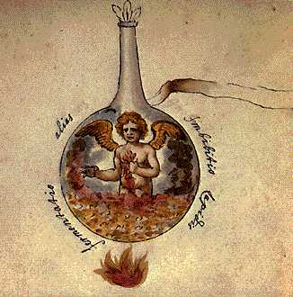
Another fermenation, the Imbibition of the stone.
This red sulphur is inbibed with five parts of its bodies weight of fresh mercury, gradually and by degrees, through seven separate imbibitions, and the sequence having been revolved in heat in the wheel of nature for one month.
They pass over the putrefaction and now the ruling words.
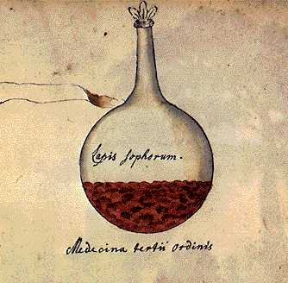
The stone of the wise.
The medicine of the third order.
A month having been completed, the omnipotent king or our stone arises, the perfect medicine of the third order in its projection able to transmute all metals.
Let the eternal God be praised and may his grace be unceasing.

The Second Book
