Solomon TRISMOSIN
Splendor Solis
Alchemical Treatises of Solomon Trismosin, Adept and Teacher of Paracelsus
Including 22 Allegorical Pictures Reproduced from the Original Paintings in the Unique Manuscript on Vellum, Dated 1582, in the British Museum.
With Introduction, Elucidation of the Paintings, Aiding the Interpretation of their Occult Meaning, Trismosin’s Autobiographical Account of his Travels in Search of the Philosopher’s Stone,
A SUMMARY OF HIS ALCHEMICAL PROCESS CALLED THE RED LION,
And
EXPLANATORY NOTES
By J.K.
London: Kegan Paul, Trench, Trubner, and Co., Ltd.

INTRODUCTORY
When in the period of the Renaissance, men’s minds were waking from the long sleep of medieval darkness, Solomon Trismosin, on of he les known Adepts of Alchemy, went forth in search of that secret knowledge, the possession of which leads to Alchemical Adeptship. His romantic Wanderings in Quest of the Philosopher’s Stone he has himself described, and if he declares to have reached that Eldorado of Hermetic Knowledge wherein is found the prized Philosopher’s Stone, although we may feel inclined to dot is word, we are, nevertheless not in a position to entirely dispute his statement.
For since the discovery of radioactive substances chemical theory has vastly changed. The very Elementarality of the chemical Elements is questioned, and the alchemical idea, that Metals can be decomposed into three ultimate principles: SALT, MERCURY, and SULPHUR, may not be so absurd after all.
Let us therefore examine the actual documents remaining of the Alchemists, especially those of reputed Adepts, that they may be studied by the Light of the most recent research of Chemical and Physical Science, and the Riddle of the Hermetic Sphinx may yet be solved.
In the book before us -- provided with those wonderful allegorical pictures, executed by an unknown artist, Trismosin in veiled language and by means of artistic Symbols reveals his mind about that mysterious and disputed subject – the Red Tincture – the Philosopher’s Stone.
Here then is a rare, and at one time, highly prized Alchemical Classic, written by an Adept, rescued from the oblivion of over three centuries -- why not give the book a fair trial?
It evidently has a two-fold meaning, and like the Book in Revelations is written within and without.
As a Guide to Physical and Spiritual Adeptship, SPLENDOR SOLIS stands both for GOLD SPLENDOR and SOUL SPLENDOUR, and intends to convey to Secret of Physical Alchemy by the text, and of Spiritual Alchemy by the Allegorical pictures.
For this reason, as Photography cannot reproduce the beautiful colorings of the Manuscript’s original paintings, a minute description of the 22 pictures, fully aware of their Mystic meaning, has been inserted in the middle of the text of SPLENDOR SOLIS, that the allegorical importance of the figures may not be overlooked. Their Mystic Meaning seems to be identical with that of the 22 keys of the Tarot, and they observe the same order.
For the Spiritual Interpretation of these Mystic Pictures, the above-mentioned minute Descriptions will be found to be very suggestive. For as observed, SPLENDOR SOLIS has both a Physical-Alchemical, and a Spiritual-Mystic meaning.
The Alchemical theory describes in veiled terms a Gold Process, possibly the very process of which Kieswetter observes, in his History of the Occult Sciences, that it stretches through the History of Alchemy like a Sea-Serpent.
It may, for all that be the true Process, that has been transmitted by tradition, and the Sea-serpent may be a living aquatic monster, that has survived the Deluge and other Cataclysms in some deep sea cave.
It is with the Philosopher’s Stone as with the Sea-serpent, some say they have seen it, while the whole mass of mankind has not; but the evidence of the few who have seen, outweighs the opinion of the many who have not.
A thing still is, though people know nothing about it.
Like Argon or neon, it may be universal, and remain universally unknown, yet, nevertheless, it exists.
What is unknown, may be ignored, but, although we know nothing about it, it is there, for all that.
Whether we consider Alchemy as a Science of Occult Chemistry, or as a Kabbalistic Art of Spiritual Regeneration, the process SPLENDOR SOLIS endeavors to communicate is equally remarkable and curious.
As a Spiritual-Mystic book, SPLENDOR SOLIS stands not only for imparting knowledge of the Splendour, or Occult Chemical, possibly Radioactive and Creative Power of Dissociated and Spiritualized Gold, it intends also the Mystic GOLD --- the DIVINE SOUL, the GOD and GOLD of TRUE HERMETIC PHILOSOPHY.
The SECRET of HERMETIC SCIENCE or PHILOSOPHY is as its name indicates: SOUL-KNOWLEDGE.
Hermetic Science does not relate to material thinks, but uses Alchemical symbols as a blind for SPIRITUAL REALITIES. It is an Alchemy of the MIND and SOUL, a SPIRITUAL ALCHEMY.
Thus is ACOB BHMEN an adept of Hermetic Philosophy, but not an Adept in Physical Alchemy. In His Philosophy the Philosopher’s Stone is a Symbol for Divine Illumination, and the mastery, or Great Work, relates to the Regeneration of the Soul.
A study of the Work of Jacob Behmen, especially of the AURORA --- The SUN --- or SOUL --- rise in the Mind, will give an idea of the Life of God in the Soul of man.
One should, however attempt to understand the inner meaning of Behmen’s phraseology, before reading any of his Works, as otherwise they are merely curious, but studies esoterically they are Divine.
BEHMEN --- the name has been naturalized in England 300 years ago, and is preferable to the German BOEHME --- frequently uses the word TINCTURE. His definition of it is that it gives luster to metals, and color and fragrance to flowers. It is the Life. For when TINCTURE vanishes, pallor and decay result. It is the SPIRIT of the CREATOR, the FATHER of ALL, for Life is SOUL, and the Creator is the SOUL of all things and beings who uphold all with His Everpresence.
Therefore we say the SOUL-POWER is the SOLE-POWER in NATURE. It is the supreme Mind that rules all, and of which Man’s mind is a part. The identity of the man-God with the God-Man was known to the Divine Philosophers of all time. Thereon is based all Divine Philosophy. It is the proof of the Truth of the Occult, the OCCULT TRUTH.
Out of the Ether comes Man’s Soul, a part of the Creator, living by His Everpresence, bearing within a Man’s Mind, which is capable of knowing all things.
As man’s Mind unfolds, nature’s secrets are revealed, and her Forces are invaded, showing that Mind rules the All, and Man’s Min is ONE with the ALL-MIND of the CREATOR.
The fact that man can master Nature, shows, that he has and is a part of the Power that maintains the Universe. The Creator thinks as man thinks, and when man thinks as the Creator thinks his Thought is TRUTH.
The object of our being here, is to gain Experience. T is our Duty to ascend to the heights of the Mind, and take stock of Existence, in as far as it affects us. Knowledge thus gained will be the starting point of our mental career beyond. Wisdom acquired here, is the beginning of Divine Wisdom. Many do not gain Wisdom, but all gain Experience. Those who rise to the height of their being, may or may not, give out their view to the world, or to that portion that knows of them; the main thing is to rise to a coign of vantage, and get the Mind-View, that the Soul may be re-born in the flesh, and while having experience of Matter, to master it.
Est in Mercurio Solis quod quaerunt Sapientes.
J.K.

This Book is Named
Splendor Solis
or
Splendour of the Sun
And is divided into seven parts, in which is described the Hidden Mystery of the old Philosophers, as well as all that Nature requires to clearly accomplish the whole Work, including all the added things; After which no one shall be Advised to grapple with the Mystery of the Noble Art with his own Senses.
I am the Way and even Road,
Who passes here without a Rest,
Will find a goodly Life abode,
And in the End be ever Blessed.
PLATE I --- Splendor Solis
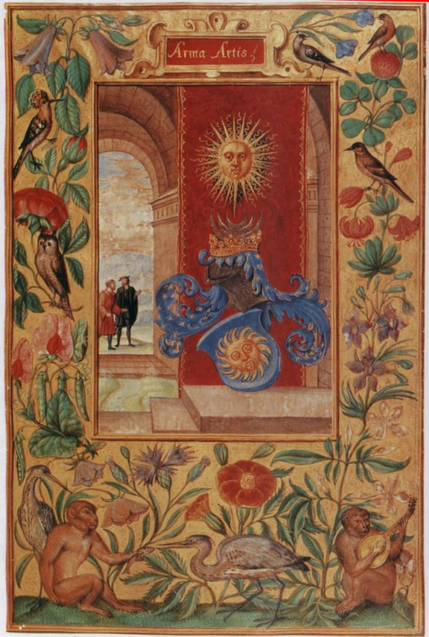

PREFACE
ALPHIDIUS, one of the old Philosophers, said: ‘Every one who does not care for the trouble of obtaining the Philosopher’s Stone, will do better in making no enquiries at all than only useless ones’.
The same also says RHASES, in his book LIGHT OF LIGHTS: ‘Let it be said then to all, I hereby admonish them most earnestly, that none be so foolhardy to presume to understand the unknown intermixture of the elements, for as ROSINUS says: “All who engage in this Art, and are wanting the knowledge and perception of things, which the Philosophers have described in their books, are erring immensely; for the Philosophers have founded this art in a natural beginning, but of a very hidden operation. Though it is evident that all corporal things originate in and are maintained and exist of the earth, according to Time and Influence of the Stars and Planets, as Sun, Moon and the others, together with the four qualities of the elements, which are without intermission, moving and working therein, thereby creating every growing and procreating thing in its individual form, sex, and substance, as first created at the beginning by God, the Creator, consequently all metals, originate in the earth of a special and peculiar matter produced by the four properties of the four elements, which generate in their mixture the metallic force, under the influence of their respective planets.
All this is well described by the natural master ARISTOTLE, in the fourth Book METEOROLOGICORUM, when he says, that QUICKSILVER is a matter common to all metals. But it must be known that first in Nature is the compound matter of the four elements.
In acknowledging this property of Nature, the Philosophers called their Matter MERCURIUS, or QUICKSILVER.
How this MERCURIUS takes the perfect form of Gold, silver or other metals through the working of Nature need not be mentioned here. The teachers of Nature’s Philosophy describe it sufficiently in their books.
Upon such is based and founded the ART of the Philosopher’s Stone; for it originates in Nature, thence follows a natural end in a just form, through just and natural means.

PLATE II --- The First Treatise
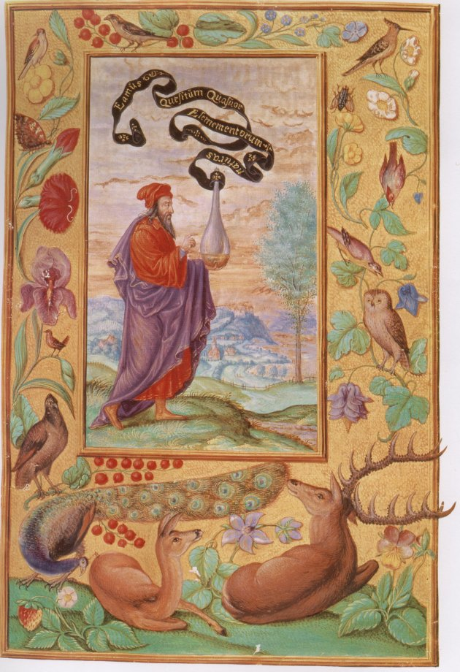
THE FIRST TREATISE
In the Following Treatise We shall Discourse on the Origin of the Stone of the Philosophers and the Art How to Produce It.
The Philosopher’s Stone is produced by means of the Greening and Growing Nature.
HALI the Philosopher, says thereof: “This Stone rises in growing, greening things’. Wherefore when the Green is reduced to its former nature whereby things sprout and come forth in ordained time, it must be decocted and putrefied in the way of our secret art. That by Art may be aided, what nature decocts and putrefies, until she gives it, in due time, the proper form, and our Art but adapts and prepares the matter as becomes Nature, for such work, and such work provides also, with premeditated Wisdom, a suitable vessel.
For Art does not undertake to produce Gold and Silver, anew, as it cannot endow matter with its first origin, nor is it necessary to search our Art in places and caverns of the earth, another way to work and with different intention from Nature, therefore does Art also use different tools and instruments.
For that reason can Art produce extraordinary things out of the aforesaid natural beginnings such as Nature of herself would never be able to create. For unaided Nature does not produce things whereby imperfect metals can in a moment be made perfect, but by the secrets of Our Art this can be done.
Here Nature serves Art with Matter, and Art serves Nature with suitable instruments and method convenient for nature to produce such new forms; and although the before mentioned Stone can only be brought to its proper form by Art, yet the form is from Nature. For the form of every thing be it living, growing, or metallic comes into existence by virtue of the interior force in matter --- except the human soul.
But it must be borne in mind that the essential form cannot originate in matter unless it is by the effect of an accidental form, not by virtue of that form, but by virtue of another real substance, which is the Fire or some other accidental active heat.
By way of allegory, we take a hen’s egg; in this the form of the chicken can not take shape, without the presence and aid of accidental form, which is the inter-mixture of the red with the white, by virtue of the heat coming from the hatching hen, and although the egg is the hen’s material, nevertheless it cannot develop either its real or accidental form, otherwise than by putrefaction, which is caused by the influence of warmth, so can also neither the real nor the accidental form of the Philosopher’s Stone originate in their natural matter without the agency of Putrefaction or Decoction, of which we shall speak hereafter.
PUTREFACTION takes place when the natural heat of a moist body is expelled by an external heat, or else when the natural heat of the subject is destroyed by cold. For then the natural warmth leaves everything and gives room to putrefaction.
The Philosophers do not mean this kind of Putrefaction. Their Putrefaction is a moistening of dry bodies, that they may be restored to their former state of Greening and Growing.
In this process of Putrefaction, moist and dry are joined together and are not destroyed, but the moisture is quite separated from the dryness, then it is necessary to separate the dry parts that turned to ashes.
This Incineration the Philosophers will also not have, but they will have their Putrefaction, which is a drying, trituration and calcinations, to be done in such wise, that the natural moisture and dryness be united together, but separated and dried up from the superfluous moisture that is destructive.
Even as the food is being absorbed on entering an animal’s stomach, that it may be digested and changed and afterwards supply the feeding force and moisture necessary to its existence and augmentation of nature, and be separated of its superfluous parts. How then everything has to be fed in its way according to its nature will be shown in the aforesaid Philosopher’s Stone.

PLATE III --- The Second Treatise
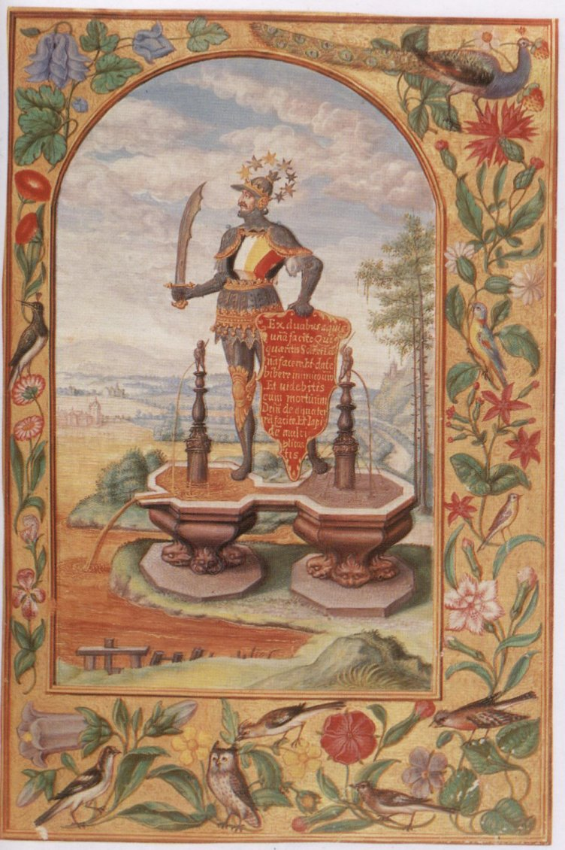
SECOND TREATISE
MATTER AND NATURE OF THE PHILOSOPHER”S STONE
Morienus says: You shall know that the whole work of this Art ends in two Operations hanging very close together, so that when the one is complete, the other may begin and finish, this perfecting the whole Mastery. But as they only act on their own matter, it is necessary to give more particulars about it. GEBER says in his SUMMA PERFECTIONIS MAGISTERI IN SUA NATURA ‘that Nature produces the Metals from Mercury and Sulphur’, and to the same effect we see FERRARIUS speak in his TREATISE ON ALCHEMY, in the 25th chapter, that from the beginning of the Origin of Metals, nature also uses a slimy, heavy water, mixed with a very peculiar white subtile earth, which resolves the former into a steam and vapour, raises it in the veins or crevices of the earth and decocts, steams and collects it together so long, till at last dryness and moisture completely unite, thereby forming the substance which we call Mercury, and which constitutes the peculiar and very first Matter of all metals, and again he treats of it in the 26th chapter as follows: ‘Those who will imitate nature, are not to use Mercury only, but Mercury mixed with Sulphur, but not the common Mercury and Sulphur, but those only which Nature herself has mixed, well prepared and decocted into a sweet fluid. In such a Mercury Nature has begun with primary action and ended in a metallic nature, having thus done her part, leaving the rest for Art to complete her work, into a Perfect Philosopher’s Stone.
From the aforesaid it will be seen that he who will proceed properly in this Art, shall according to all Philosophers, begin there nature has left off, and shall take that Sulphur and Mercury which nature has collected in its purest form, in which took place the immediate action, which otherwise cannot be accomplished by anybody without art.
In order to receive the force that penetrates such subtle Matter, some Alchemists calcinate Gold that they may dissolve it, and separate the elements until they reduce it to a volatile spirit or to the greasy fumes of Mercury and Sulphur, and this then is the nearest matter, that combines most closely with gold, and receives the form of the occult Philosopher’s Stone, this matter is called the Mercury of the Philosophers, about which ARISTOTLE, speaking to ALEXANDER the King, says: ‘Choose for our Stone that wherewith kings are decorated and crowned’.
Though this Mercury alone is the matter and the one only thing and a combination of other things, and in its names, that no one can find out the true meaning from the writings of the Philosophers, and this is done for the purpose as ROSINUS says, ‘that every one may not get at it’.
It is at the same time a way of producing effects and a vessel wherein all things multiply themselves, because of the adjustment of all things comprised in Nature.
For now the Philosophers say: ‘Dissolve the thing, and sublimate it, and then distil it, coagulate it, make it ascend, soak it, dry it, and ever up to an indefinite number of operations, all of which take place at the same time and in the same vessel’. ALPHIDIUS confirms this and says: ‘You must know that when we dissolve we sublimate as well and calcinate without interruption,’ and if our Corpus is being thrown into the water, for the purpose of dissolution, it first turns black, then separates itself, dissolving and sublimating, unites itself with the spirit which is its origin and birth.
It has been compared as analogous to all things in the world, visible or invisible, possessed of a soul or not, corporeal or animal, dead or alive, mineral or vegetative; analogous to the elements and their compositions, to things hot and cold, further to all colors, all fruits, all birds, and in short to all things between Heaven and Earth, and among all these are belonging to this Art the aforesaid operations, which are explained by the Philosophers in two words, ‘Man’ and ‘Woman, or ‘Milk’ and ‘Cream’. He who does not understand these does not understand the preparation of this Art.

PLATE IV --- The Third Treatise
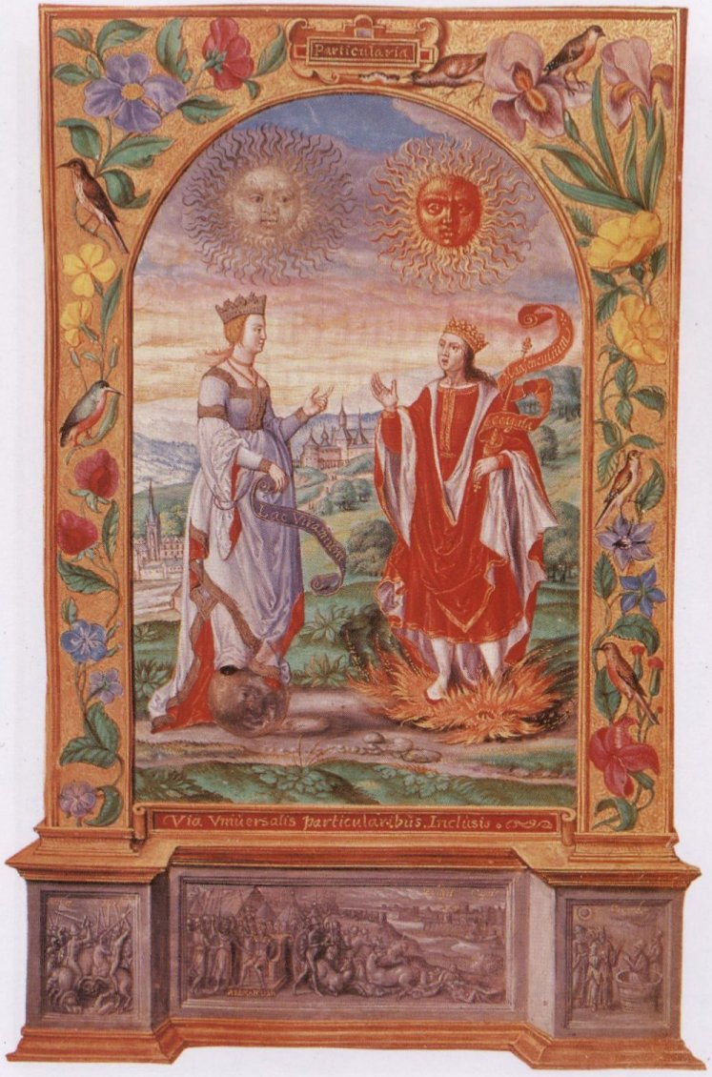
THE THIRD TREATISE
NOW FOLLOWS THE MEANS WHEREBY THE WHOLE WORK OF THIS MASTERY IS PERFECTED; EXPLAINED BY A FEW SUITABLE ILLUSTRATIONS, PARABLES, AND VARIOUS APHORISMS OF THE PHILOSOPHERS.
HERMES, a Father of Philosophy, says: ‘It is indeed needed that at the End of this World, Heaven and Earth should meet and come home. Meaning by Heaven and Earth the aforesaid two Operations; but many doubts arise, before the Work is finished. That the following Figures may be better understood we give a few Parables in illustration :---
AND THIS IS THE FIRST PARABLE :
GOD created the Earth plain and coarse, and very productive of Gravel, Sand, Stones, Mountains and Valleys, but through the influence of the planets, and the working of nature, the Earth has been changed into many forms. Outside these are hard stones, high mountains and deep valleys, and strange things and colors are inside the Earth, as, for instance, Ores and their beginnings, and with such things earth has come from the original form, in the following manner: Where the Earth first began to grow large, or to expand and multiply, the constant operation of the Sun-Heat also formed in the interior of the Earth a sulphury vaporous and damp heat, penetrating her through and through. This penetrating work of the Sun’s heat caused in the cold and damp of the Earth, the formation of large quantities of vapor fumes, fog and gas, all of which grow with the length of time strong enough to follow their tendency to rise, thus causing on the Earth’s surface eruptions, forming hill and dale, etc. Where there are such hills and dales, there the Earth has matured and most perfectly mixed with heat and cold, moisture and dryness, and there the best ores may be found. But where the earth is flat there has been no accumulation of such fumes and vapors, and there no ores will be found, while the uplifted part of the soil, especially, such as has been slimy, loamy, and fat, and has been saturated with a moisture from on high; got soft again, forming dough-like layers one on top of the other, which in the course of time, under the influence of the Sun’s heat, become more and more firm, hard and baked; and other ground as gravel and sand, brittle and yet soft, hanging together like grapes, is too meager and dry, and has not received enough moisture, consequently it could not form itself into layers, but remained full of holes, like badly prepared pap, or like a mealy dough, which has not been watered enough; for no earth can become stone, unless it be rich and slimy and well mixed with moisture.
After the drying up of the water by the Sun’s heat, the fat substance will keep the ground together, as otherwise it would remain brittle and fall to pieces again. That which has not become perfectly hard as yet, may become so, and turn to stone, under the constant influence of the sun’s heat and nature, as well as the aforesaid fumes and gases originating in the properties of the elements, which are by these means still being operated upon in the interior of the earth, and when they seize upon watery vapors with a pure, subtle earthy substance, then they form the Philosophers’ Mercury, but when they are solid and brought to a fiery, earthy and subtle hardness, then will the Philosophers’ Sulphur be the result.
About this Sulphur HERMES says: ‘It will receive the powers of the highest and lowest planets, and with its force it penetrates solid things, it overcomes all matter and all precious stones’.
PLATE V --- The First Parable
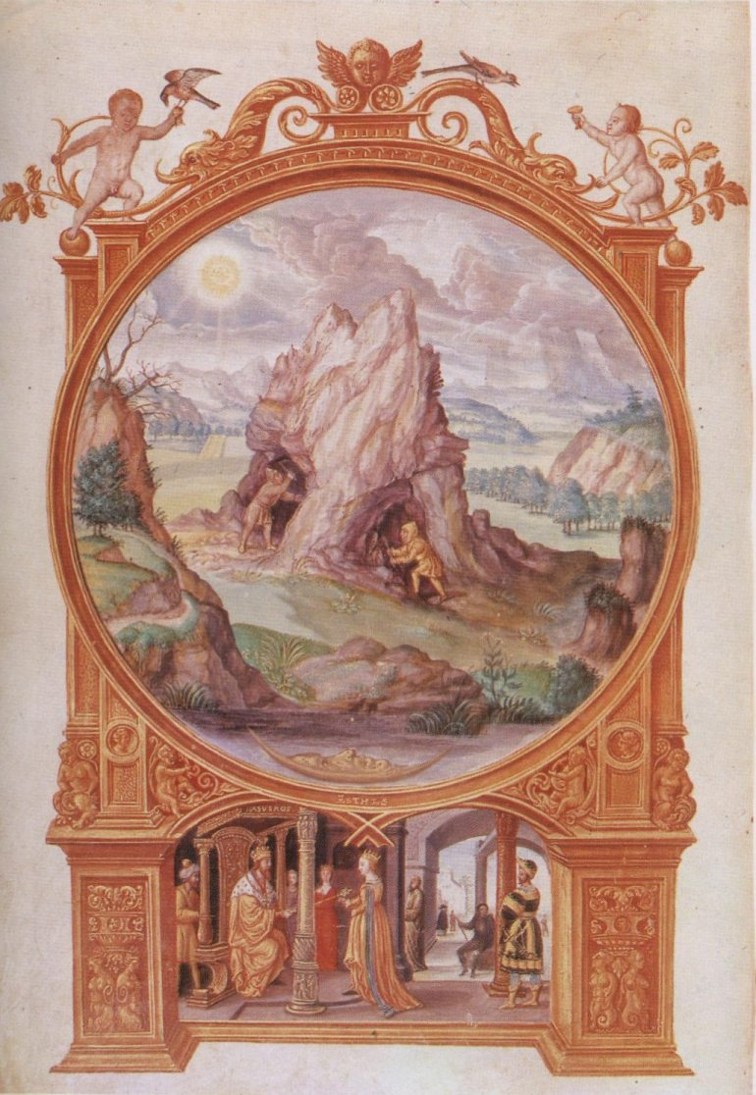
PLATE VI --- The Other Parable
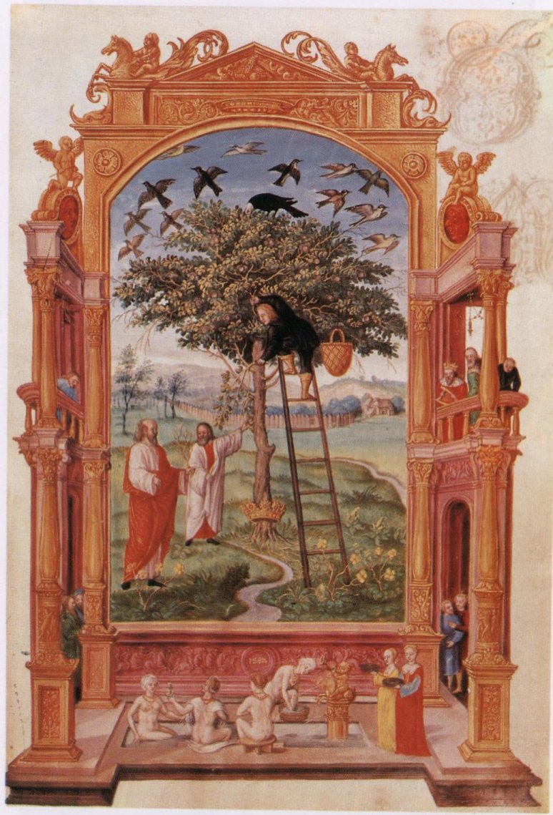
THE OTHER PARABLE
HERMES, the First Master of this Art, says as follows : ‘The Water of the Air, which is between Heaven and Earth, is the Life of Everything; for by means of its Moisture and Warmth, it is the medium between the two opposites, as Fire and Water, and therefore it rains water on earth, heaven has opened itself, and sent its dew on earth, Heaven has opened itself, and sent its Dew on earth, making as sweet as honey, and moist. Therefore the Earth flowers and bears manifold colored blooms and fruits, and in her interior has grown a large Tree with a silver stem, stretching itself out to the earth’s surface. On its branches have been sitting many kinds of birds, all departing at Daybreak, when the Ravenhead became white. The same tree bears three kinds of Fruit. The First are the very finest Pearls. The Second are called by Philosophers TERRA FOLIATA. The Third is the very purest Gold. This Tree gives us as well the fruit of Health, it makes warm what is cold, and what is cold it makes warm, what is dry it makes moist, and makes moist what is dry, and softens the hard, and hardens the soft, and is the end of the whole Art. Thereof says the Author of ‘The Three Words’, ‘The Three Moistures are the most precious Words of the whole Mastery’. And the same says GALENUS, when he speaks of the Herb LUNATICA or BERISSA. Its root is a Metallic Earth; it has a red stem, spotted with black, grows easily and decays easily, and gains Citrine Flowers after three days; if it is put in Mercury, it changes itself into perfect Silver, and this again by further decoction changes into Gold, which then turns hundred parts of Mercury into the finest Gold. Of this tree speaks VIRGILIUS, in the sixth book of the AENEIDE, when he relates a Fable, how AENEAS and SILVIUS went to a tree, which had golden branches, and as often as one broke a branch off, another one grew in its place.
PLATE VII --- The Third Parable
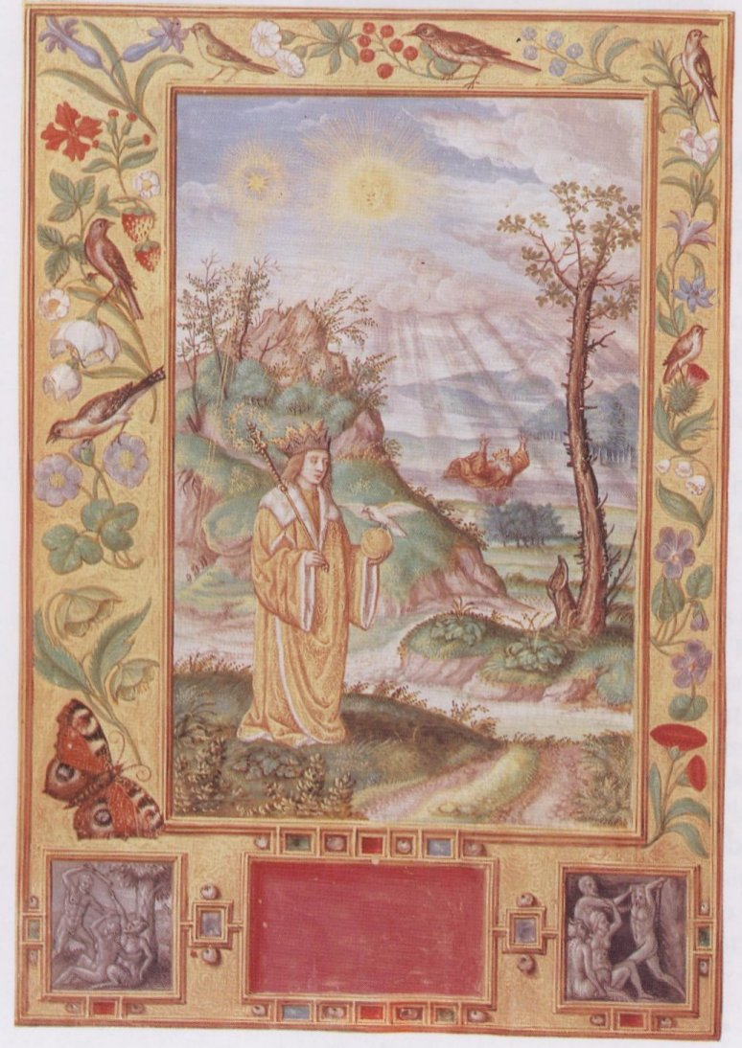
THE THIRD PARABLE
AVICENNA says in the Chapter on the MOISTURES : --- ‘When Heat operates upon a moist body, then is blackness the first result’. For that reason have the old Philosophers declared they saw a Fog rise, and pass over the whole face of the earth, they also saw the impetuosity of the Sea, and the streams over the face of the earth, and how the latter became foul and stinking in the darkness. They further saw the King of the Earth sink, and heard him cry out with eager voice: ‘Whoever saves me shall live and reign with me for ever in my brightness on my royal throne’, and Night enveloped all things. The day after they saw over the King an apparent Morning Star, and the Light of Day clear up the darkness, the bright Sunlight pierce through the clouds, with manifold colored rays, of brilliant brightness, and a sweet perfume from the earth, and the Sun shining clear. Herewith was completed the Time when the King of the Earth was released and renewed, well appareled, and quite handsome, surprising with his beauty Sun and Moon. He was crowned with three costly crowns, the one of Iron, the other of Silver, and the third of pure Gold. They saw in his right hand a Sceptre with Seven Stars, all of which gave a Golden Splendor, and in his left hand a golden Apple, and seated upon it a white Dove, with Wings partly silvered and partly of a golden hue, which ARISTOTLE so well spoke of when he said: ‘The Destruction of one thing is the birth of another’. Meaning in this Masterly Art: ‘Deprive the thing of its Destructive Moisture, and renew it with its own Essential one which will become its perfection and life’.
PLATE VIII --- The Fourth Parable
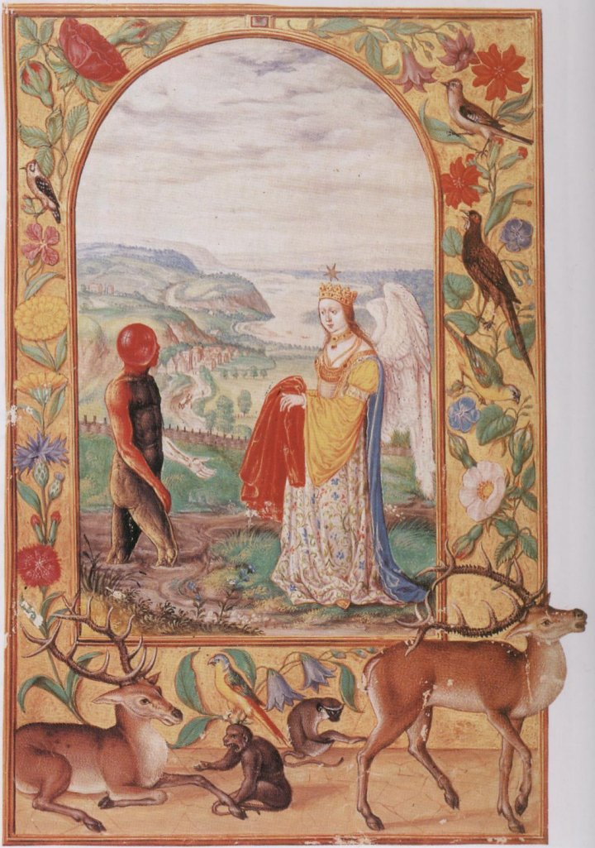
THE FOURTH PARABLE
MENALDUS the Philosopher, says: ‘I command all my descendants to spiritualize their bodies by DISSOLUTION, and again to materialize the spiritual things by means of a gentle decoction.
Mentioning which SENIOR speaks this: ‘The Spirit dissolves the body, and in the Dissolution extracts the Soul of the Body, and changes this body into Soul, and the Soul is changed into the spirit, And the Spirit is again added to the Body, for this it has stability’. Here then the body becomes spiritual by force of the Spirit. This the Philosophers give to understand in the following Signature, or Figure: They saw a man back like a negro sticking fast in a black, dirty and foul smelling slime or clay; to his assistance came a young women, beautiful in countenance, and still more so in body, most handsomely adorned with many-colored dresses, and she had wings on her back, the feathers of which were equal to those of the very finest white peacock, and the quills were adorned with fine pearls, while the feathers reflected like golden mirrors. On her head she had a crown of pure gold, and on top of it a silver star; around her neck she wore a necklace of fine Gold, with the most precious Ruby, which no king would be able to pay; her feet were clad with golden shoes, and from her was emanating the most splendid perfume, surpassing all aromas. She clothed the man with a purple robe, lifted him up with herself to Heaven’. Therefore says SENIOR: ‘It is a living Thing, which no more dies, but when used gives an eternal increase’.
PLATE IX --- The Fifth Parable
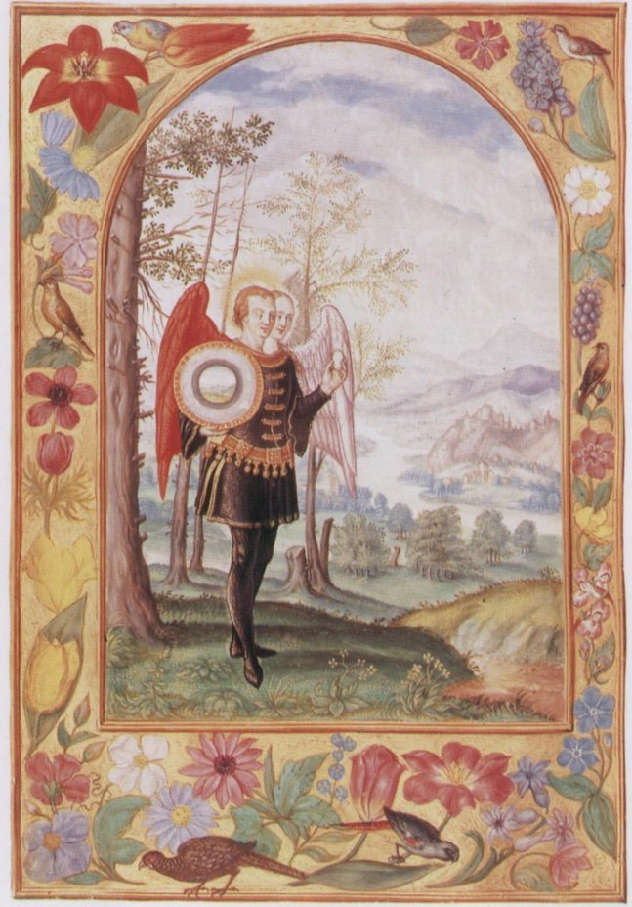
THE FIFTH PARABLE
The Philosophers give to this Art two bodies, namely: Sun and Moon, which are Earth and Water, they also call them man and Wife, and they bring forth four children, two boys, which are heat and cold, and two girls, as moisture and dryness. These are the Four Elements, constituting the QUINTESSENCE, that is the proper white MAGNESIA, wherein there is nothing false. In conclusion SENIOR remarks: ‘When these five are gathered together, they form ONE substance, whereof is made the natural Stone, while AVICENA contends that: ‘If we may get at the Fifth, we shall have arrived at the end’.
So let us understand this meaning better. The Philosopher takes for example an Egg, for in this the four elements are joined together. The first or the shell is Earth, and the White is Water, but the skin between the shell and the White is Air, and separates the Earth from the Water; the Yolk is Fire, and it too is enveloped in a subtle skin, representing our subtle air, which is more warm and subtle, as it is nearer to the Fire, and separates the Fire from the Water. In the middle of the Yolk there is the FIFTH ELEMENT, out of which the young chicken bursts and grows.
Thus we see in an egg all the elements combined with matter to form a source of perfect nature, just so as it is necessary in this noble art.
PLATE X --- The Sixth Parable
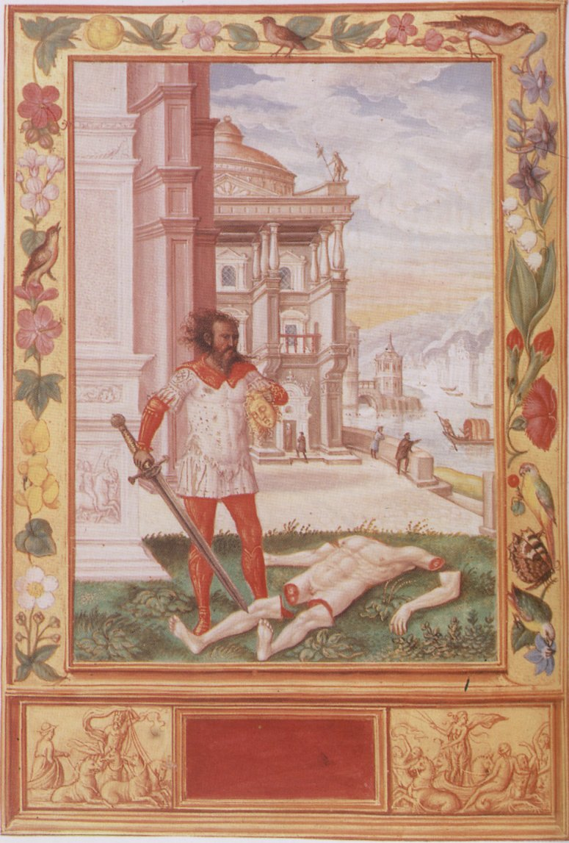
THE SIXTH PARABLE
ROSINUS relates of a vision he had of a man whose body was dead and yet beautiful and white like Salt. The Head had a fine Golden appearance, but was cut off the trunk, and so were all the limbs; next to him stood an ugly man of black and cruel countenance, with a bloodstained double-edged sword in his right hand, and he was the good man’s murderer. In his left hand was a paper on which the following was written: ‘I have killed thee, that thou mayest receive a superabundant life, but thy head I will carefully hide, that the worldly wantons may not find thee, and destroy the earth, and the body I will bury, that it may putrefy, and grow and bear innumerable fruit’.
PLATE XI --- The Seventh Parable
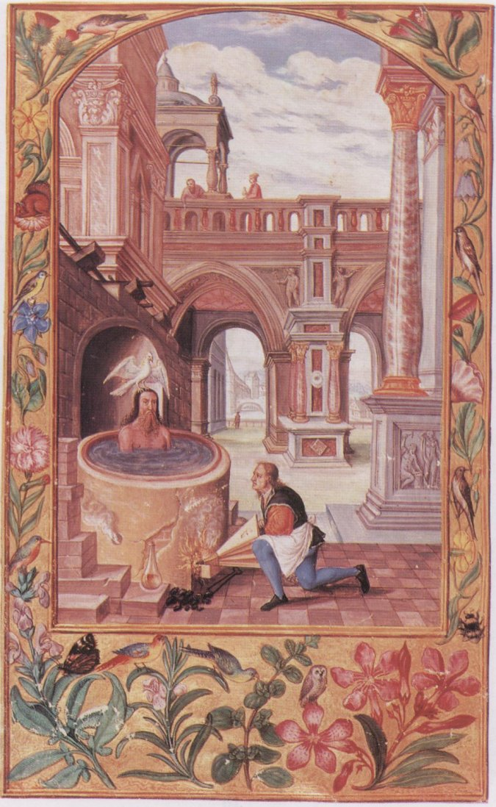
THE SEVENTH PARABLE
OVID the old Roman, wrote to the same end, when he mentioned an ancient Sage who desired to rejuvenate himself was told: he should allow himself to be cut to pieces and decoct to a perfect decoction, and then his limbs would reunite and again be renewed in plenty of strength.

THE FOURTH TREATISE
OF THE MEANS BY WHICH NATURE ATTAINS HER ENDS
PLATE XII --- The Fourth Treatise, Firstly.
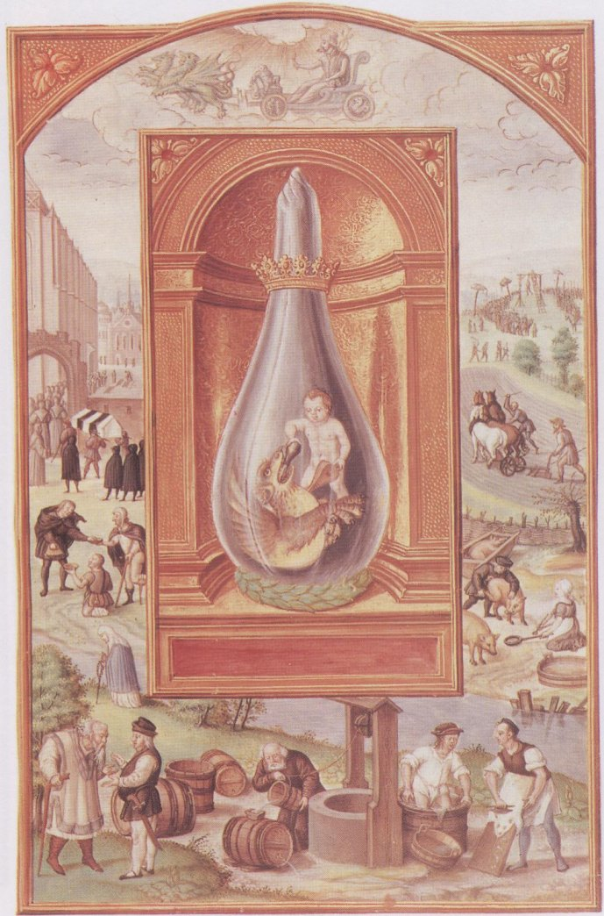
ARISTOTLE in the Book of Origins speaks thus: ‘Sun and man create a Man, for the Sun’s force and spirit give life, and the process has to be gone through seven times, by means of the Sun’s heat’.
But as the Philosophers in their work have to aid Nature with Art, so have they also to govern the heat according to the Sun, so as to create the before-mentioned Stone, which as well has to undergo seven processes. For such a work requires FIRSTLY, a heat powerful enough to soften and melt these parts of the earth that have become thick, hard and baked, as mentioned by SOCRATES when he says: that the holes and cracks of the earth will be opened to receive the influence of Fire and Water.
PLATE XIII --- The Fourth Treatise, Secondly
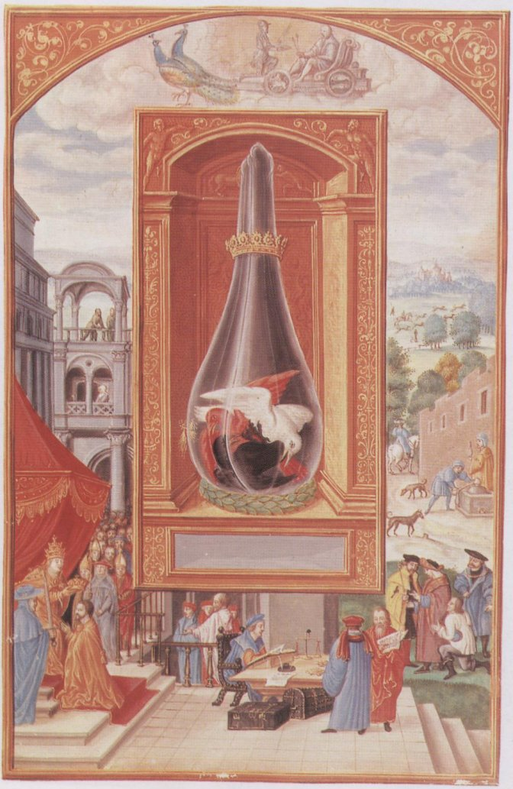
SECONDLY: The Heat is necessary, because through its power the earth becomes freed from darkness and blessed with light instead. In regard to which SENIOR says: that heat turns every black thing white, and every white thing red. So, as water bleaches, fire gives off light, and also color to the subtilized earth, which appears like a Ruby, through the tinging Spirit she receives from the force of the fire, thus causing SOCRATES to say: that a peculiar light shall be seen in the darkness.
PLATE XIV --- The Fourth Treatise, Thirdly
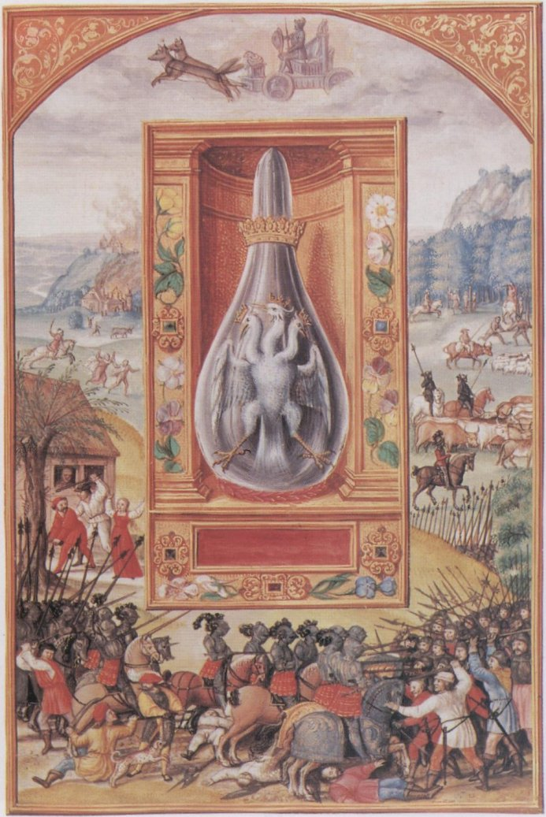
THIRDLY: The Heat causes earthly things to be penetrated by a Spiritual Force, of which it is said in the TURBA: Spiritualize the bodies and make Volatile that which is Fixed. Of which RHAZES reminds in his ‘LIGHT OF LIGHTS’, as follows: ‘A heavy body cannot be made light without the help of a light body, nor can a light body be kept pressed down to the ground without the aid of a heavy body.
PLATE XV --- The Fourth Treatise, Fourthly
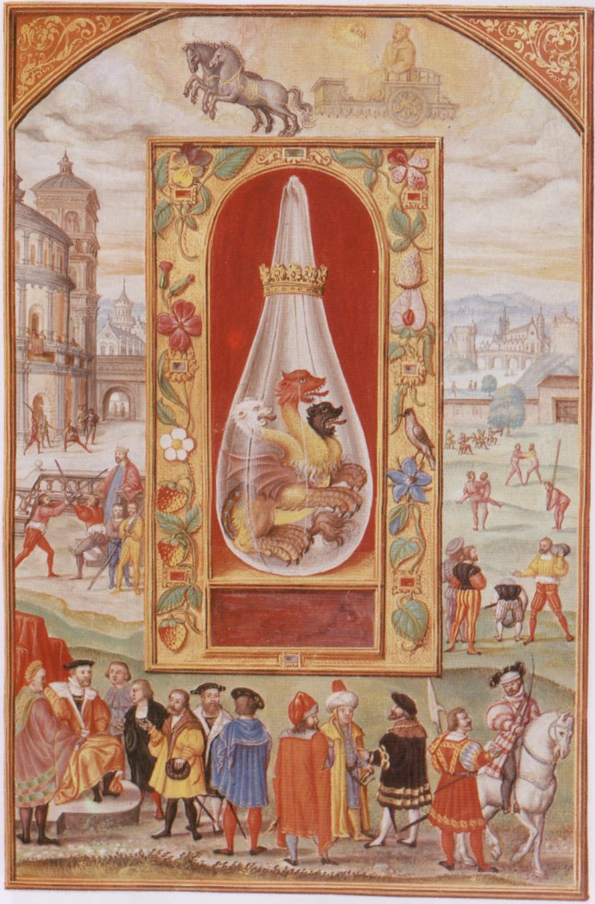
FOURTHLY: The Heat cleanses that which is unclean. It throws off the mineral impurities and bad odours and nourishes the Elixir. In mention of which HERMES advises: Separate the gross from the Subtil, the earth from the fire. Whereof says ALPHIDIUS: The earth can be molten and becomes fire. Thereon says RHAZES: There are several Purifications preceding the perfect preparation, namely, Mundification and Separation.
PLATE XVI --- The Fourth Treatise, Fifthly
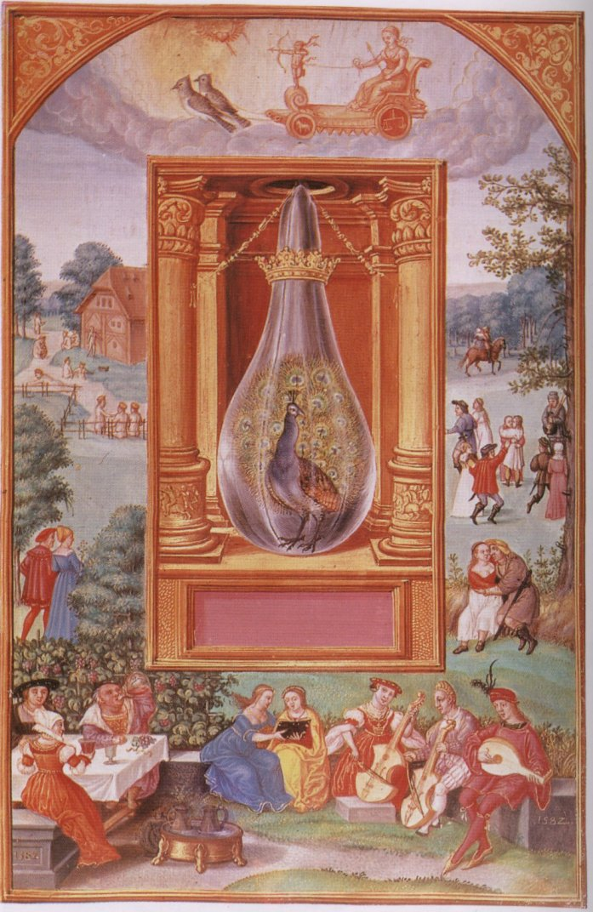
FIFTHLY: The Heat works elevatingly, for by its force the spirits hidden in the Earth are raised up into the air, wherefore the philosophers say, that whosoever can bring to light a hidden thing, is a Master of the Art.
The same is meant by MORIENUS, when he teaches that ‘He who can recreate the SOUL is able to see color, and also by ALPHIDIUS saying: ‘Hence it is that this Combat raises upwards, or else you shall not gain by it’.
PLATE XVII --- The Fourth Treatise, Sixthly
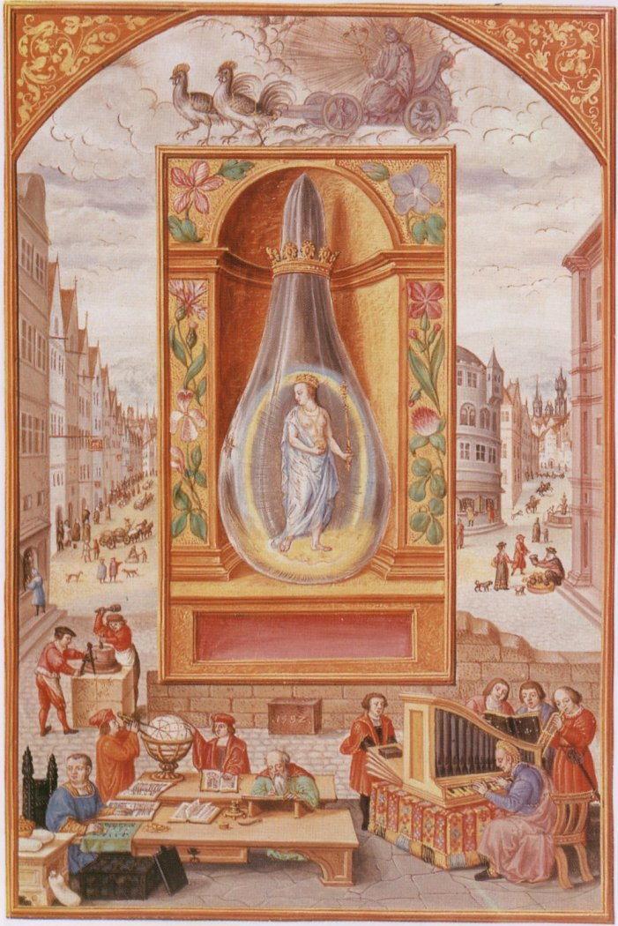
SIXTHLY: The Heat warms the cold earth, that while cold was half dead. Thereof says SOCRATES: When Heat penetrates, it makes subtle all earthly things, that are of service to the matter, but come to no final form while it is acting on the matter. The Philosophers conclude on the mentioned Heats in brief words, saying: Destil seven times and you have separated the destructable moisture and it takes place as in one distillation.
SEVENTHLY: Is the Force of the heat thus mixed with heat in the earth, that it has made light the collected parts and resolved them so as to surpass the other elements, and therefore this heat shall be modified with the Moon; ‘Extinguish the Fire of one thing with the Coldness of another’, says CALID.
PLATE XVIII --- The Fourth Treatise, Eighthly
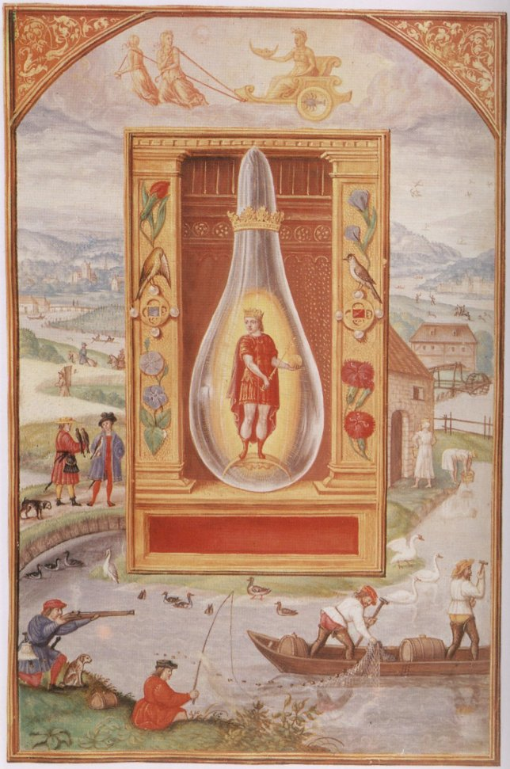
EIGHTHLY, AUCTOR DE TRIUM VERBORUM, the author of THE THREE WORDS gives in his writings a peculiar method to govern the HEAT or the FIRE saying: ‘When the Sun is in Aries, he indicates the First heat, or Grade of the Fire, which is weak because the heat is under the Rule of the Water, but when the Sun is in Leo, then it indicates the Second Grade, which is hotter because the great coldness of the Water being under the Rule of Air. In the Sign of Sagittarius is the Third Grade, this being not of a burning heat, and under the Rule or Order of Rest and Pause.

THE FIFTH TREATISE
ON THE MANIFOLD OPERATIONS OF THE WHOLE WORK
IN FOUR CHAPTERS
PLATE XIX --- The Fifth Treatise, Part I, Chapter 1
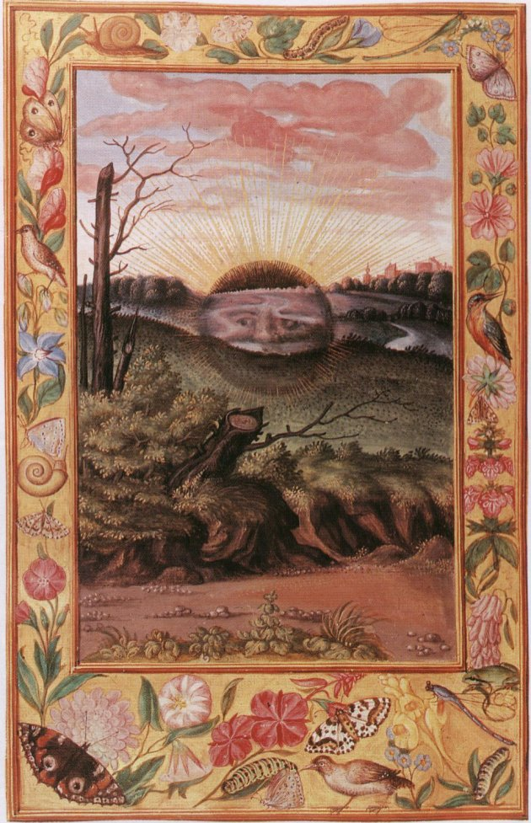
THE FIRST CHAPTER
DISSOLUTION is the FIRST Operation which has to take place in the Art of ALCHEMY, for the order of R which is the much spoken of MERCURY. The LIVING SILVER dissolves the adjoined pure SULPHUR.
This Dissolution is nothing but a killing of the moist with the dry, in fact a PUTREFACTION, and consequently turns the MATTER black.
PLATE XX --- The Fifth Treatise, Part I, Chapter 2
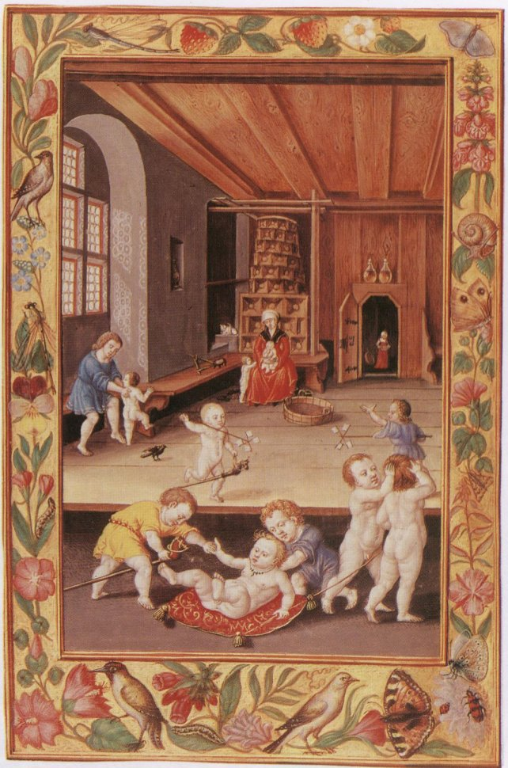
THE SECOND CHAPTER
The next is COAGULATION, which is turning the WATER again into the CORPUS or MATTER, meaning thereby that the SULPHUR, which before was dissolved by the LIVING SILVER, absorbs the same and draws it into itself.
The Water that turned to Earth, which the Corpus has absorbed, necessarily shows other and manifold colors. For if the properties of an operating thing alter, so must the thing operated on alter.
Because in the DISSOLUTION the LIVING SILVER is active, but in the COAGULATION it is passive, operated on.
Wherefore is this Art compared to the play of children, who when they play, turn undermost that which before was uppermost.
PLATE XXI --- The Fifth Treatise, Part I, Chapter 3
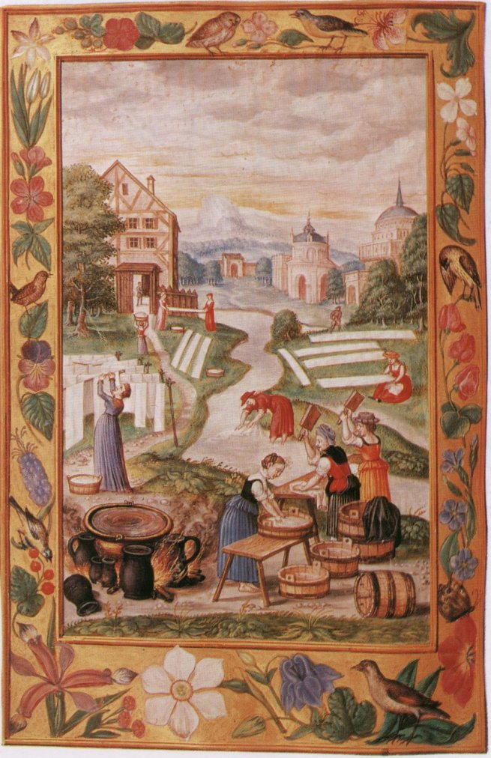
THE THIRD CHAPTER
The Third is SUBLIMATION, distilling the before-mentioned moisture of the earth, for if the water is reduced into the earth, it is evaporated into the lightness of the air, and rises above the earth, as an oblong cloudlet, like an egg, and this is the Spirit of the FIFTH ESSENCE, which is called the TINCTURE, ANIMA, FERMENTUM, or the OIL, and which is the very next matter to the STONE OF THE PHILOSOPHERS.
For from the Sublimation remain ashes, which by virtue of their own AIR, given to them by GOD, dissolve themselves by a moderate heat, after which earth of a fiery nature and property remains calcined at the bottom of the glass.
This being the proper philosophical sublimation, by means of which the perfect method is carried out. And this is why this Art is compared to Woman’s Work, which consists in cooking and roasting until it is done.
PLATE XXII --- The Fifth Treatise, Part I, Chapter 4
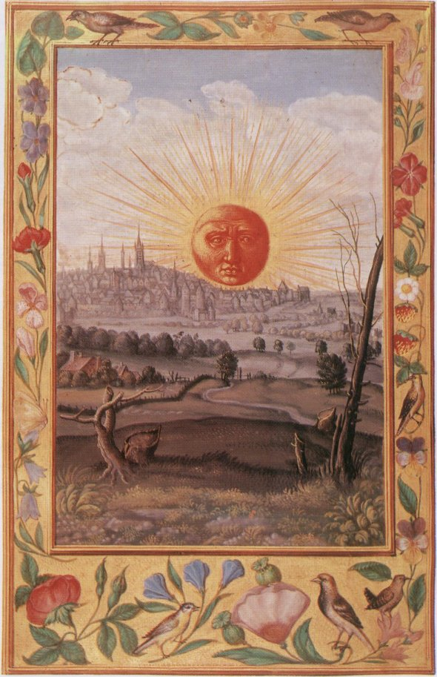
THE FOURTH CHAPTER
The fourth Chapter sheweth the last or fourth thing belonging to this water which has been separated from the earth, be again joined to the earth. The one thing must be done with the other, of the Stone is to be made perfect.
The reason why all natural things are put together in a body is, that there may be a united composition.
In these last four Chapters is all contained wherewith the Philosophers have filled the whole world with innumerable books.

DESCRIPTION OF THE SPLENDOR SOLIS PICTURES
THE FIRST PICTURE
Two men are approaching an arched doorway at the left side of the picture, LEAVING A LANDSCAPE BEHIND THEM, to come into the apartment of the building --- in which are to be seen two beautifully executed Golden Suns --- One of the men is a little in advance of and is addressing the other. He is clad in a red robe and blue stocking simply. The other is more luxuriously dressed, but in black and with a sword or staff at his right side. The floor below the archway is tiled, or tessellated, the round has a green sward. From this archway forward in the picture to the foreground where there are three flat stone-steps, upon which rests a sky-blue shield (heraldic). On the shield is painted the lowest Golden Sun, upon which is superimposed a black helmet or casque surmounted by a flowing, from above, blue drapery, studded with golden stars. This lower Sun and shield lies aslant, about 45 degrees. The mouth is rounded and is so painted as to resemble a human face, each eye has the same peculiarity; thus there are THREE FACES shewn on the ONE. The eyes themselves seem as if suffused with tears, the mouth as if the tongue was slightly protruding and parched, the face blotched or mottled as from Smallpox, or impure living.
The rays at the circumference are in groups and radiate curvedly, thus:
The upper Sun stands higher up in theair and is radiant, but thoughtful and serious.
The golden halo around it alternately straight and wavy, as:
The lowest one of all being longer than the others and pointing in the center of three dark moon-like crescents, as:
Each one below being larger than the other. The picture is surmounted by the motto: ARMA ARTIS in red and embellished with a golden margin, on which is painted two monkeys, one giving a fish to a heron, while the other is playing upon a guitar --- an owl, a hoopoe, and other birds, with fruits and flowers complete the picture.
THE SECOND PICTURE
A man clothed in red robe, with a red cap and a purple outer cloak. In his left had he holds a long-necked flask, cucurbit, or glass retort, which is one-third filled with a yellowish transparent fluid, partly luminous, and to which he is pointing with his right finger thoughtfully, whilst walking upon the foreground of a beautiful landscape. The margin shows a golden ground, upon which is painted Deer, Peacock, Bee, Butterfly, Birds, Red Currants, and Flowers. From the neck of the cucurbit flows a black ribbon upon which is printed in gold letters: EAMUS QUESITUM QUATUOR ELEMENTORUM NATURAS.
THE THIRD PICTURE
A Knight in dark armour ornamented with Gold, with a drawn sword in his right hand, and in his left he holds a red banner or shield, on which is inscribed in gold letters: EX DUBAU AQUI UNAM FACITE, QUI QUAERITIS SOLE ET LUNA FACERE ET DATE BIBERE INIMICO VINO. ET VIDEBITIS UM MORTUUM. DEINDE DE AQUA TERRA FACITE, ET LAPIDEM MULTIPLICATIS.
He stands upon two fountains, with a foot on each. That to the right, is surmounted by a little nude figure of a boy from which runs a black fluid and overflows by a joining conduit into the left fountain which is also surmounted by a little nude figure of a girl, but from this one runs a golden liquid into the receptacle below, which transmutes by its blending the black stream all into golden water. This fountain overflows and forms a large golden lake, which is seen stretching away in the distance, and around which is seen a village and beautiful landscape.
THE FOURTH PICTURE
Represents on right side a King in red and gold robes, with golden crown on head and standing upon a blazing fire, holding a scepter in his hand with a scroll upon which is: COAGULA MASCULINUM in golden letters. He is talking to a Queen robed in blue with red lining to dress, holding a blue scroll with LAC VIGINIS inscribed in gold letters. She stands upon a dark full Moon with both feet, over hear head in the air is a faint silvery Sun, which has its eyes directed toward the King enquiringly and hopefully. Above his head is a golden red Sun which has its eyes directly towards her sorrowfully.
A City and landscape lies behind. Around margin are birds and flowers on Gold. On top of picture is the motto: PARTICULARIA. At the bottom is inscribed: VIA UNIVERSALIS, PARTICULARIBUS INCLUSIS
THE FIFTH PICTURE
Represents two men quarrying at a rock and digging for Gold. A bronzed crescent Moon lies floating in the water on the foreground. Underneath is the word: ESTHER, and below that is the interior of the Palace of the King AHASUEROS, who is seated on a throne, handing his Sceptre to the Queen. On the top of the picture are two nude figures of children. One holding a bird in his hand, the other at the corner opposite is feeding another bird.
THE SIXTH FIGURE
Contains a Tree with Golden Branches and fruit, having a golden crown encircling the root. Upon a ladder with SEVEN ROUNDS and leaning against the tree; stands a man, on the sixth and seventh rounds dressed in black, with golden leggings or boots, holding a branch out to a man below, dressed in a red robe, which is enveloped by a whitish purplish robe. He has given previously a similar branch to another man dressed in a whitish purple robe enveloped in a red robe. Underneath the picture is an open bath in which four women are bathing, a golden fountain pours forth a jet of water into the bath, two ladies are standing near the batch, one is dressed in yellow and the other in red, each hold out some black roundish thing like a hat or dish. Through the doorway to the right are to be seen two men, one dressed in blue and the other in purple, and to the left of the picture are seen two men in green. On a gallery above and behind, is a man looking over, dressed in blue, while opposite is a King in red, with attendants, one in green, another in black, also looking down towards the bath. The bathers have each two strings of gold beads (charms) round their necks. Upon the tree above is perched a large black bird with a white head, pecking at the fruit, while THIRTEEN varied coloured birds are in the act of flying away to the air. An humble looking landscape with a simple cottage in the mid-distance. Mountains in the background and olden branches and flowers springing up out of the ground complete the picture.
THE SEVENTH PICTURE
Represents a Queen, or young King, draped in Ermine and Gold embroidered robe, loose and flowing, holding in right hand a scepter surmounted by seven Golden Stars, and in left a golden ball. In the middle distance a King is seen swimming or drowning in the sea, and reaching his arms out as if for help to save his life. A Golden Sun shines overhead, throwing its rays downward towards the Queen. To the Sun’s left is a luminous Star surrounded by a golden halo, which is also directing its rays towards the Queen, or young King. The margin is in gold with Butterfly, Strawberries, birds and flowers. At base are two small Entaglios like bluish-grey pictures, that to the left represents a man naked and striking with a bludgeon a woman who is sitting on the ground alongside of a Satyr, both of these are holding up their arms to ward off the blow. A tree grows by their side. That to the right is very similar, only there is a fourth male figure, who is standing up, and tries to stay the man with the bludgeon from striking the other two. The landscape with hill, and walk on foreground and distant view is very beautiful. Golden tipped flowers peer above the foliage, and the whole scene is one would not feel desirous of altering or attempting to improve upon.
THE EIGHTH PICTURE
Depicts a Queen with angels’ wings --- and most gorgeously dressed. She has a golden crown and neck ornaments, with golden chains, yellow sleeves and flowing. Skirt of dress ornamented with a flowing green foliage pattern and red and blue flowers. From her left shoulder hangs a blue drapery with gold edges, her slippers are red and gold. In her hand she holds a crimson robe edged with gold, which she is holding out to a naked black man who is standing to the knees in a black mud pool. His left arm is white and slightly soiled. His right arm, neck, and head is blood red. He holds his right hand over his right thigh towards and as if to cover his nakedness. He stands with right side towards us and on the profile is seen a circular transparent glass globe, just covering head all but profile, through this globe are to be seen on the organ of Self-esteem, the right cheek bone, and over the right eye, three luminous spots, in each of which is seen a small red cross. The Queen seems to e encouraging and sympathizing with him. A landscape with lake is seen in the distance. Village, roadway with a few distant people walking and boat sailing on lake, with islands in extreme distance.
There is a silver star over the Queen’s crown. Two Deer, two monkeys, and parrot on base, and flowers upon Gold on margin complete the picture.
THE NINTH PICTURE
Standing on the foreground of a magnificent Claude-like picture is an exquisitely formed figure of a man dressed in black with golden edging and cross button bars of red and gold in front. A red and gold waistband with a fringe of golden tassels of ornaments. He has two heads and necks. One a man’s with sandy hair and blue eyes, without beard or moustache, the other a beautiful female face with blue eyes and fair or reddish hair. A golden emanation or halo radiates from the man’s head while a silvery radiation proceeds from the female. His face is to the left of the picture but to her right and his profile overlaps the back part of her head just as far as the edge of the right eye, so that both faces are seen pretty fully. He has attached to the right shoulder a crimson wind, and she has a faint purple and white wing. In the left hand he holds a Golden Egg, which both are intent upon, and I his right hand he holds a Circular Shield, the edge of which is encircled with gold and orange, an inner circle next of which is encircled with gold and orange, an inner circle next of grayish mottled or marbled appearance, then an inner circle, but narrower, of dark green and blue ring inside this, in the center of which is a tiny landscape, like the one seen through a double concave in a tube. Birds, Flowers, and Grapes upon a golden ground complete this picture.
THE TENTH PICTURE
Represents a ferocious villainous man with wild disheveled lack hair, clothed in red with an outer garment of white shaded with pale purple and having a drawn sword in his right hand. In his left he holds the golden head of a fair skinned corpse of a man which lies at his feet freshly mutilated. The arms and legs are separated fresh and clean, showing the clear red flesh freshly cut. This scene is represented in the open grounds attached to a palace. A river runs past on which are plying gondolas. Castles and fine mansions are seen in the distance, as when Venice was in her glory, a city of palaces. Several people are strolling and lingering on the grounds, within view, but these are oblivious to the scene here depicted. Some golden tips are to be seen on the green foliage --- upon which this ghastly scene is represented.
At the base underneath are seen two small golden pictures, one on the left represents a King driving four river horses, behind which is a female figure in a boat, holding two reins which are attached to the horses, and thus is the boat drawn along.
The picture to the right represents a female in a boat holding a three-pronged fork, a trident, in her right hand (without a handle), with reins in the left hand, guiding three river horses. A Satyr and two females are going on before; and two more are coming up behind, one of the latter sits on the back of a Merman. Birds and Flowers on a Gold ground complete the picture.
THE ELEVENTH PICTURE
In a court yard of a magnificent palace and under a corridor is a circular furnace on which is an iron vessel or copper boiler filled with water, and in which is a naked man with red skin, breast high. On his head stands a dove, with outspread white wings, blue shaded. A man is blowing at the furnace with a pair of bellows very intently and anxiously. His inner garment is red, his nether garment blue, his coat black and edged with blue, slippers black, apron white, hair longish and careless. The whole figure betrays the workman. Two figures are observed on a distant raised corridor. One a female dressed in red and carrying a flask in her hand; the other a man, dressed in pale purple and looking towards the man in the hot bath. Alongside of the workman is a Cucurbite on retort of glass, tongs and coals for fire. In two niches in the wall are to be seen figures of Mercury and Jupiter. At the base or pedestal of a column is an intaglio or bas-relief of Vulcan working as a blacksmith, with an assistant having his arm raised with hammer, as if assisting. Birds and flowers on golden ground finish the margin of this picture.
THE TWELFTH PICTURE
Represents in a highly ornamental niche as the leading feature of the picture, a large upright glass cucurbit, or retort hermetically sealed, standing upon a green wreath, and is circled at narrow part by a red and gold crown, which comes about one-fourth down from the top. Inside this cucurbit is seen a naked child, holding a black flask or crucible in his right hand with which he is pouring its contents down the throat of a Dragon, or some horrid aquatic monster, having claws scales and finny wings. The legs and breasts are covered with peacock feather spots. In the left hand the child holds a pair of small bellows, with which he points towards the heart of the monster. An allegorical figure of Mercury seated on a car with a caducean rod in his left hand and a reaping hook in his right, an infant reclining before him on the car, and driving two green and gold Dragons or Monsters) surmounts the niche. On the base of the picture is seen a river from which an old man draws water and which he is pouring into a barrel, but which is running out as fast as he fills it in. A man with naked legs is trampling animal skins in a tub, while a currier is shaving the hair of a hide in front of him. An old man bent with age is soliciting alms from a comfortable well-to-do middle-aged man. On the right margin and beyond the river is a woman feeding a pig. A man is seizing another pig by the leg with one hand and ear by the other, while another pig is seen pent up in a box as if for being carried away, or slaughtered. Beyond is seen a man with a team of four horses drawing a plough, while another man is in the act of beating one of them, a brown one, three of them are brown, and one is white, which seems to be pulling very willingly. Beyond this is seen one man cudgeling another man whose hands are tied behind his back, and further off still is a large crown of people round a gallows where a man is being hanged. On the left margin are two cripples seeking and receiving alms from a gentleman, while beyond them is seen a funeral procession going into a graveyard close to a large cathedral. Four mutes dressed in black, follow the coffin which is carried by four men, and is shaped like the roof of a cottage, painted white with two black bands across it.
THE THIRTEENTH PICTURE
In another similar niche and Cucurbit surmounted in like manner by a Golden Crown or Coronet. Inside the glass vessel are three doves or birds. One is colored RED, one WHITE, and the third BLACK. The two former are busy pecking or fighting the black one, which they have got down upon its back and it is throwing up its claws in self-defense. The WHITE pecks it UNDER THE TAIL, while the RED pecks it upon the HEAD. Golden scintillations appear opposite the head of the red bird on the surface and outside the glass. Underneath the base of the niche is a massive wide staircase inside the Vatican. Half way up this stair is a wide landing space, upon which are a table and two black trunks or boxes. On the table are a pair of scales, two heaps of gold, ink bottles, desk and a printed paper hanging over the side of the side of the table. A man clad in red and blue with blue cap, is sitting at the table, upon a black chair, looking over a large book, two men are standing at the table, apparently conversing together. The one is dressed in a blue robe with scarlet cap and comforter hanging down his back; the other has a crimson robe edged with Gold, his head is uncovered and he holds an illumined book in his hand. Two steps up to the left, is a man on his knees, upon a crimson carpet. He is draped in red and gold, two steps further up sits the Pope robed in red and gold with his triple golden crown, in the act of placing a crown upon the kneeler’s head. The Pope is surrounded by numerous Cardinals, etc. Others are seen as if conversing farther back. Two are seen working a still or retort in the quadrangle, while a pack of hounds and people are seen hunting in the distance. One humble looking suppliant is seen near at hand upon one knee, as if soliciting some favor from these gentlemen who are outside the place and evidently of some authority.
Surmounting the niche is a mythological picture of a man with two arrows in his hand and sitting upon a car which is drawn by two peacocks, upon the wheel of the car is Sagittarius and on the other Pisces. A knight is upon one knee handing him a dish, etc. The radiance of the Sun shines behind him. (Jupiter in Sagittarius and Pisces).
THE FOURTEENTH PICTURE
A similar glass cucurbit in a golden niche. Inside the glass, standing upright is a white bird shaded blue, with three heads, each of which is decorated with a golden crown.
Above the niche is a mythological representation of Mars with shield and spear and sitting upon a car with a coiled up serpent before him. On the front wheel is Capricorn and on the hind one Cancer. The car is drawn by two Foxes. Underneath and around margin is a War going on between helmeted and armoured horsemen with red and gold skirts outside their armor, and the populace on foot armed with spears, etc. Burning of houses, and seizures of cattle are to be seen in the distance. Possibly intended to represent scenes from the Swiss War of Emancipation.
THE FIFTEENTH PICTURE
A similar cucurbit set in a crimson niche upon the margin of which is painted strawberries, peapod, flowers and a bird. In the Cucurbit is a Monster Dragon, having three heads, and long necks attached to one body, similar to that in the twelfth Picture. The heads are turned to the right, that nearest us is white, the center one is red, the farthest one is black, the necks are all speckled green. The niche is surmounted by an allegorical representation of a King in golden garments and seated upon a light green two-wheeled chariot drawn by two horses with golden harness, over golden-tipped clouds. There is the figure of Leo on the wheel. Before the King is a golden Sun aslant and on a level with his face, from or through whose influence, the King is able to radiate a golden emanation or halo all around. Sun in Leo. Underneath the Cucurbit is a King in a royal red and golden robes with black inner clothing and cap, sitting upon a dais on a lawn. Before and around him are ten Courtiers in magnificent and varied apparel, another is upon a horse beautifully caparisoned.
The right marginal continuation of the landscape shews well-dressed men at athletic sports, stone heaving, wrestling, archery, etc. On the left margin is a King with crown on head, and dressed in blue and purple robes, standing watching two men at sword exercise, two boys are standing by holding in their hands two other swords, as if in attendance upon them. Others are seen at sword practice in the background. Landscape with River and Castles in the distance.
THE SIXTEENTH PICTURE
A similar but more fanciful golden niche. The top part has a circular opening in it to allow the pointed top of the glass Cucurbit to pass through it. From this point are suspended two golden chains, the other ends of the chains are attached to two pillars at the sides of the niche, about three fourths of the height of it. Inside the Cucurbit is a beautifully painted peacock looking down upon a group of musicians below. One of them is playing a guitar, and another a viol. A lady dressed in red and gold also is playing a viol, while another lady in blue and one in yellow and gold are singing a concert, at the left side of the picture are two gentlemen and a lady at table drinking wine and eating grapes. At the right side stretches a landscape and various men and women in couples walking about. To the left is seen a running stream in which many people are bathing. The niche is surmounted by the figure of a lady draped in red and gold, holding a golden arrow in her hand and sitting in a red golden car. On one wheel is Aries and on the other Libra, Venus in Aries and Libra. The car is drawn by two doves over golden tipped clouds. Before her on the car stands a small figure of Cupid with bow and arrow in the act of shooting, while she holds him from behind with a golden cord. A red heart appears in the sky, above him radiant with gold and penetrated by a red arrow. A golden radiant sun rests upon the heart, top cut off by the top line of the picture.
THE SEVENTEENTH PICTURE
A similar Cucurbit and golden niche as in picture number Fourteen. In the Cucurbit is the figure is a Queen with the upper part of her body naked, but with a pale blue robe thrown loosely round the rest of the body except the feet and ankles are bare. Around her is an oval shaped halo like a blue and yellow rainbow. Beneath her feet is a golden side face of the Sun. Flowers are painted on the golden margin of the niche which is surmounted by the blue figure of a man upon a blue car, holding in his hand a radiant caducean rod, the car is drawn by two cocks, on one wheel are Gemini and on the other Virgo. Mercury in Gemini and Virgo. Underneath the base of the niche are two philosophers studying a Globe. Another is writing at a desk, while another is sitting at the table counting gold into bags. To the right side of the table is an ancient organ, which is being blown by a man at the bellows behind, while the organist manipulates the keys in front. Two choristers and a man playing a brass wind instrument completes this group of Commerce, Science, Literature and Music, while sculpture is represented by two men operating with hammer and chisels upon a short stone pedestal. The back ground depicts a very busy and prosperous commercial city, possibly Venice.
THE EIGHTEENTH PICTURE
In another golden niche surrounded with birds and flowers upon a golden ground stands a similar glass flask or cucurbit. Inside of the same is a youthful boy King, dressed in red and gold. His legs are bare from above knees to lower part of calves. Boots red and gold. He holds a golden ball in his left, a scepter in his right hand. He stands upon a crescent moon, convex side up, and wit an oval halo of light, throws a great radiance all around, of deep yellow and gold emanations. The niche is surmounted by a golden car drawn by two female figures in red and gold. In the car is seated a female figure holding a crescent Moon in her hand concave side up. On the wheel of chariot is the sign of Scorpio (Moon in Scorpio). Underneath the base of niche is a river with water birds on its surface, fishermen in a boat casting nets, others fishing with rods and shooting, hawking, washing clothes I river, hunting, riding, boating and ships sailing, are seen in middle and extreme distance, and a mill-wheel is being moved by the stream near the foreground.
THE NINETEENTH PICTURE
It is a most dismal and curiously dark weird-like subject. A bleakish stunted landscape, with black blighted withered trees in foreground. A MONSTER BLACK SUN is in great part sunk below the ground, yet visible and partly rising above the ground at the center of the landscape --- or middle distance. The rising of this pall-like bristly black sun, overspreads and hides totally the body of the true sun, which lies beyond; for, behind --- is to be seen golden radiation of the true sun, which illuminates with its golden tinted light a nice landscape in the extreme distance. The clouds above are red and the building seen afar off (in the extreme distance) are also red and glowing. Faint golden radiation are to be seen shooting through all this foreground blackness, as if emanating from the true hidden sun which lies behind all.
The margin has caterpillars, butterflies, small birds, snails, flowers, etc., on a golden ground, which completes the picture.
THE TWENTIETH PICTURE
In a long room are to be seen ten children of various ages at play. Six of these are naked, three are clad in blue and one in yellow. Toy hobby horses without legs, little paper windmills. A cushion made into a car to give rides upon, etc., form the chief amusements. The mother sits at the extreme end of the room nursing a baby in her lap and keeping a watchful eye over the family. She is dressed in red and gold, with a black cape. A JACKDAW is seen hopping about the floor. The cat in the corner. A bath and basin on the floor ready for use, and two bottles containing a yellowish liquid is seen on a shelf over the door. A servant girl is seen through the door in another apartment busy at work.
Butterflies, caterpillars, moths, flies, snails, fruit and flowers upon a gold ground complete this picture.
THE TWENTY-FIRST PICTURE
Has a river and landscape. A cauldron with fire underneath and a few black earthenware vessels surrounding it are on the immediate foreground. On the foreground are nine women washing and wringing clothes, hanging out, drying, and bleaching.
Houses, Minaretted Castles, etc., beautify the landscape. Birds, berries, butterflies and flowers, on a golden ground complete the margin.
THE TWENTY-SECOND PICTURE
Exhibits the Sun just risen, golden red, serious thoughtful and severe looking. The eyes seem so penetrating as if they would search into and question your inmost soul. The landscape has the sanctity of night over it and is of a blackish grey tint. A city is seen on the hill right underneath the chin of the Sun. Yet it is seemingly wrapped in night. There is nothing like life stirring, all appears wrapped in night and sleep, and as if the Sun had stolen UPON THEM UNAWARES AT VERY EARLY MORNING, and was unable to give any light to the Earth or waken the people.
A few blasted trees on foreground and middle distance alone show faint tinges of Gold.
Birds, strawberries and flowers on a golden ground in the margin completes the picture which is PREGNANT WITH THE DEEPEST MYSTERY that can be known to man here or hereafter.

ON THE GOVERNMENT OF THE FIRES
If a thing is deprived of its heat, then there is no motion in it. In the order of nature the Father changes into the son, which means that the Spiritual is materialized, and the Volatile made permanent.; or that the Sun and Moon have come home. Of these two planets SENIOR speaks also: ‘I am a hot and dry Sun, while thou, LUNA, art cold and moist, and when we shall rise in the order of our most ancient nobility, a burning light will be poured into us’. Whereby he is indicating that through the knowledge and mastery of the ancients the renewals of the moistures will be received, and Sun and Moon become transparent.
The SCALA PHILOSOPHORUM treats of the FIRE as follows: ‘The Heat or Fire of the whole work is uniform, for some say that the heat of the first regimen shall be as the warmth of a brooding hen, others that it ought to be as the natural warmth of the digestion of food and nourishment of the body, while some take the heat of the Sun, when she is in the sign of ARIES, as the proper one’.
Though the stone is obtained through one operation, nevertheless has the operation of the Fire to be changed thrice. In the first operation of the work shall the heat be moderate and warm, till the matter turns black continually, and further till it turns white again. This heat is compared to the heat of the Sun when he is in ARIES and begins to move towards TAURUS. When the White appears the FIRE should be increased and continued until the perfect drying up or Calcination of the Stone; this heat is compared to the Sun’s heat when he is in Taurus and moving towards GEMINI. And when the stone is perfectly dried up, and calcined, the fire has again to be made more fierce still, until the stone becomes perfectly red, and clad with a royal coat from the fire, and this heat is compared to the summer heat, when the Sun is in LEO; that is her highest dignity, when she is in her own house. This much is enough said on the government of the FIRE.

THE FIFTH TREATISE
SECOND PART
ON THE COLOURS WHICH APPEAR IN THE PREPARTION OF THE STONE
MIRALDUS, the PHILOSOPHER, says in the TURBA: It turns black twice, yellow twice, and red twice, and therefore decoct it, for in the process of DECOCTION appear many colours, and according to these is the heat changed. And although all colours appears so are there yet but three most noticeable amongst all. The principal colours are black, white and red; between these many others appears; a yellowish one after the white, or after the first red, said by MIRALDUS, to be a perfect Colour, while CONCILIATOR calls it NOT perfect, and hardly remaining on matter long enough to be visible. But the other yellowish colour which ariseth after the perfect white, and before the first red, can be seen for some time, and is therefore a perfect colour. This is the same that MIRALDUS says above, but they do not last so long as black, white or red, which stand in the matter for four days; though black and red appear perfect a second time. But the first perfect colour is the black resulting from the mildest heat.
According to CONCILIATOR, the Whitening should take place in a mild heat, till the Black disappears. While LUCAS, the PHILOSOPHER, says in the TURBA: ‘Beware of great heat, for if you make the fire too fierce in the beginning, then will it arise red before its time, which is useless, for in the commencement of its government you ought to have first the black, then the white and lastly the red’.
BALEUS, the PHILOSOPHER, says in the TURBA; ‘Decoct your composition, till you see it white, and quench it in Vinegar and separate the white from the black, for the white is a sign of approaching Fixation, it needs to be extracted from the black by means of the fire of calcinations, for the augmented heat separates the superfluous parts, leaving them but a coarse earth under the Matter, like a coarse black ball, not capable of mixing with the pure and subtle matter of the Stone’. That is what the Philosophers say: ‘The red must be extracted from the white, for there is nothing superfluous in it, nor is there anything separated, but all turns perfectly red, for which purpose they order to make a stronger fire’. Whereof PYTHAGORAS says: ‘The more the colours change the stronger you must make the fire, of which you must not be afraid. For the Matter is fixed in the White, and the species fly not from it’.
About these remarks the Philosopher Lucas: ‘When our magnesia is made white, it does not yield its species’. This may be sufficient on the Colours of the Secret Philosophic Work, now follows the Conclusion to it.
HERMES, a father of the Philosophers says, that ‘One should not take out the aforesaid white Magnesia until all the colours are perfect, when it will become a Water dividing itself into four other Waters, namely one to two and three to one. One third of it belongs to heat and two thirds to moisture. These Waters are the Weights of the Philosophers.
It should further be known, that the Vine which is a Sap of the Philosophers, is extracted in the Fifth, but its Wine has to be opened in the Third, and in proper Preparation.
For in Decoction it gets less, while in Trituration, it forms itself. In all this is included beginning and end. Therefore the Philosophers say that it was made perfect in SEVEN DAYS; others say in Four Days, some say in Three Times, some in Four Times, some in Ten Days, some in Forty Days, some in ONE YEAR.
TURBA and ALPHIDIUS: In the Four Seasons of the year, as : Spring, Summer, Autumn, and Winter, some others again say in a Day, in One Week or in One Month.
GEBER and ARISTOTELES, these Philosophers say: in Three years. All this is nothing else but one thing in another thing, for the Philosophers say the Operations are manifold, and so are the times, weights and names in consequence, all of which an intelligent Artist must know well, otherwise he can produce nothing.

THE SIXTH TREATISE
ON THE PROPERTIES OF THE WHOLE WORK IN THE PREPARATION OF THE PHILOSOPHER’S STONE
CALCINATION is put in the beginning of the Work as the Father of a Generation, and is of three kinds, two of which belong to the Corpus or Matter, and the third to the Spirit. The First is a preparation of the Cold Moisture, and is the beginning of our Work. The other is a fatty moisture, which burns the wood.
The Third is an Incineration of the dry earth, and gives no flames, but gives a body as clear as glass. Thus the Philosophers order their Calcination to be made, and it is accomplished with AQUA PERMANENTE, or with ACETO ACCERIMA. Such moistures are in the metals, for they are the beginning of fusion. This is proved by Hermes, when he says: ‘The water is the beginning of all soft substances, therefore the Calcination is the indication of a destructive moisture, and of an application of a foreign fiery moist subject, from which the essentiality and life originates. For this reason it is called a fusion of the incineration, taking place with the Water of the Philosophers, which in reality is the Sublimation, or Philosophic Solution, for this changes the hard dryness into a dry softness; and thus is extracted the QUINTA ESSENTIA, and separation of the elements. This takes place that those parts, which got dried and compressed by the Fire, have become subtle through the spirit, which is a resolving water, moistening the incinerated body, lessening and changing the introduced destructive heat into an airy resolution, which is the peculiarity of that element. Therefore it is called SUBLIMATION, the process by which the coarse earth becomes thin or subtle, and changed into the moisture of the water, and the cold of this water, and the warmth of the air, and the moisture of the air, turned into the heat of the fire, is a reversion of the elements, and the extracted QUINTA ESSENTIA of the elementary FAECES. And this QUINTA ESSENTIA is a radical moisture of a very high nature, tinging infinitely.
It further is the true fixation, of which GEBER says: ‘What becomes Fixed becomes Illumined, and is changed into a beautiful transparent substance. For out of it arises the SULPHUR PHILOSOPHORUM, or the ash extracted from ash, without which the whole mastery is in vain. For it is a metallic water, generated in the body, making it alive. It is an Elixir of the red and white Tincture, and a tinging volatile spirit’.
In this Work also takes place the true Ablution, or cleaning of blackness and stench, and the Dead will be made again to live by the introduction of a pure, indestructible heat and metallic moisture, supplying the tinging force, by means of which is also effected the Philosopher’s Putrefaction, spoken of at the beginning of this book, restoring what was before, and bringing to light that which was hidden. Therefore says TURBA: ‘Putrefaction is the first and demands the UTMOST SECRECY. It is the true separation of the elements, reversing them in this operation’. TURBA says further: ‘Reverse the elements, the moist make dry, and fix that which is volatile, powder it, and prepare it all carefully’. This is the Philosopher’s Trituration. Wherefore SEIOR declares Calcination to be useless, unless the result is as a powder. It is as well the Decoction of which all Philosophers speak, especially ALBERTUS MAGNUS, when he says that among all the arts none follows nature so closely as Alchemy, because of decoction and formation. For the former takes place in fiery red and metallic waters, which have most from the form and but little from matter. It is as well the Philosophic ASSATION, or roasting, for the accidental moisture is consumed by a mild fire and very great care is to be taken, that the spirit which dries up the body, may not escape from the body, as otherwise the operation would not be perfect. It is as well the Philosophers Destillation, or clarification; this being nothing but the uniting of a thing with its own essential moisture, and with the Coagulation the Philosophers complete the whole work.
Thereof says HERMES: That the Earth is its foster mother, by which he means that its power is complete when changed into a constant earth capable of producing innumerable effects, as we shall see hereafter. Nothing else can yet be effected on a more natural way than this art, when followed in truth and not in form only and appearance. This SENIOR confirmed saying: ‘There is no man living able to exercise this art without nature. Yea and with such nature as has been given us by Heaven to unite with nature’.

THE SEVENTH TREATISE
OF THE WHOLE WORKS’ MANIFOLD EFFECTS, AND WHY THE PHILOSOPHERS INTRODUCE OF MANY NAMES AND ALLEGORIES IN THIS ART OF THE PREPARATION OF THE PHILOSOPHER’S STONE
It is a common saying of the Philosophers, that whoever knows how to kill the living silver, is a master of this art, but very great attention has to be paid to their Quicksilver, for the describe it differently and manifold.
SENIOR says thus: ‘Our Fire is a Water. If you can give a Fire to a Fire and Mercury to Mercury, then you know enough’. He says further: ‘The Soul is extracted by Putrefaction, and when nothing more of the soul remains, then have you well washed the Body, that they both again are one’. Then it is called a QUINTA ESSENTIA, or a Spirit, Permanent Water or menstruum.
The TURBA also says: ‘Take mercury and coagulate it in the body of Magnesia, or in the Sulphur which does not burn, and dissolve it in the very strongest Vinegar, and in this Vinegar it will become neither black nor white nor white or red, and thus it becomes a dead Quicksilver, and is of a white colour, and before the approach of fire it becomes red’.
TURBA speaks about it as follows: ‘Lay it in Gold when it will become an elixir, that is his Tincture, and it is a very beautiful water extracted from many tinctures, it gives life and colour to all whom it is given to take’. Further the TURBA continues: ‘The Tyrian colour red is the very best; after that comes a costly Purple colour, and this is the true Quicksilver; it brings a sweet savour, and is a genuine Tincture’. From this it is sufficiently to be seen, that all Philosophers, not only ascribe the beginning of the art to Quicksilver, but the Middle and perfect end as well.
HERMES, the father of PHILOSOPHERS, speaks of it thus: ‘I have been observing a bird called the Philosophers’ ORSAN, which flies when in the Signs of ARIES, CANCER, LIBRA, or CAPRICORN, and this bird you may receive for all eternity from true minerals and precious mountain stones. Parts shall you part, and especially that which remains after the separation, and is called of the Earth’s complexion, that you see it in many colours, then will the wise men call it CERAM SAPIENTAE and PLUMBUM. In regard to this the Philosophers talk about roasting and distilling trough Days of Time, according to Number, and Division of the Parts, saying: ‘Sublimate rectify, fix till it sticks to the ground, further, incinerate and imbibe it till it flows; make it dead and alive again; file it and break it, till the secret becomes revealed and the revealed secret, separate the Elements and unite them again, extract the Soul from the Body. Further rectify Body and Spirit; make white Venus, deprive JUPITER of his bolt, harden Saturn, and soften Mars, make LUNA Citron-colored and solve all bodies in water which makes them perfect’. They also teach to roast the black Sulphur till it turns red, when they distil it all they obtain white transparent Gum like the thing which is so highly prized and called LAC VIRGINIS. Then they mix the water which is drawn off from the Virgin Milk and transfer it into a golden gum and a white transparent water, which must be left to coagulate, after which process they call it Tincture of the Wise, TINCTURA SAPIENTIAE, and a fire to the colours, one Soul one Spirit drawing, back again to home those after wandering about far away. Further, SULPHUR RUBEUM, GUMMI AUREAM, AUREUM APPARENS, CORPUS DESIDERAM, AURUM SINGULARUM, AQUA SAPIENTIAE, especially if it possesses great whiteness. The TURBA also says: ‘You should know that, unless you make the Gold first white, you will never be able to get it red, black and pure waters; the Crystalline will show itself from the Citron red. Therefore says SENIOR: ‘It is a peculiar thing, if you throw it over the other three already mixed up, so will it help the white over the citrine and the red, it will turn the colour of silver; after that it helps the red over the Citrine, and makes it white; over the white and red and makes it Citrine Golden coloured; then it helps as well the red over the Citrine, and makes it of a white colour’.
Of these things MORIENUS speaks thus: ‘Behold the perfect Citrine, and that which is altered in its Citrinity; the perfect red and the one lessened in its redness, and further the perfect black in its blackness’. Hence it is clear that the gold of the Philosophers is different to common Gold or Silver, but even to all metals. SENIOR says: ‘I am a dry and hard Iron, and nothing is like me, for I am a coagulation of the Quicksilver of the Philosophers’. TURBA says: ‘Copper and Lead become a precious Stone of the Philosophers. The Lead which the Philosophers call Red lead, is a beginning of the whole work, and nothing can be done without it; therefore some say: ‘From red lead make iron, or Crocum; from white lead make a white tincture, or tin, from tin make copper, from copper make white lead, from white lead make Minium, from Minio make a Tincture, and you have begun the Wisdom’. Although the Philosopher says that, nothing approaches Gold so nearly as Lead, for in it is the Life and all the occult Secret; but this is not meant of common Lead.
Moreover MARCASIT, of which the stinking earth wins golden scintillations, as MORIENUS says, it is also compared to ARSENIC, AURIPIGMENT and TUTIA. Others again compare it to many things not mineral at all, as to the Four Complexions, to Theriac, to the Basilisk, to blood, and such like superfluous things, among minerals to Salt, Alum, Vitriol, and other things, on account of its manifold qualities.
Above all things ALPHIDIUS warns us thus: ‘Dear Son, beware of spirits, bodies and stones which are dead, as mentioned, for in them is no way, nor would you find guidance for your purpose with them. For their force does not multiply, but comes to nothing instead, while the Salt of the Philosophers is a Tincture extracted and absorbed from the bodies of metals, like as other alkaline salts are absorbed from other bodies’.
Of this SENIOR says: ‘That at first it turns to ashes, afterwards it becomes a Salt, and at last with a great deal of labour, it becomes the mercury of the Philosophers. But the best and noblest of all is SAL AMONIAC, as confirmed by ARISTOTLE in his book of THE SEVN COMMANDMENTS, where he says, ALMISADIR, that is SAL AMONIAC, shall serve you only, for it solves the bodies, and makes them soft and spiritual’. The same says TURBA: ‘Know that the body does not tinge itself unless the Spirit which is hidden in its interior, be extracted, when it will become a water and a body of a spiritual nature, because the thick earthy substance cannot tinge, but the proper one is of a thin nature, and colors the tingent spirit of a watery nature to an Elixir, because there has been extracted a white and red fixation, of a perfect colouring, and an all penetrating Tincture, which mixed with all the metals’.

THE PERFECTION OF THE WHOLE MASTRY DEPENDS ON THESE FEW POINTS:
That the SULPHUR be extracted from THE PERFECT BODIES. They have MARS FIXED, which Sulphur is their noblest and most subtle part, a crystalline salt, sweet and savoury and a radical moisture, which if it were to remain for a year on the fire would always be like molten wax. Wherefore a small part exalteth a large quantity of common Quicksilver into genuine Gold.
On that account, the moisture or the water which is extracted from the metallic bodies, is called the Soul of the Stone, or Mercury, but its forces are named Spirit, when affecting things of a Sulphurous nature; while the solid Earth is the Body, the QUINTESSENCE is the ultimate TINCTURE. All these three are a united thing of one sole root, but having manifold effects and innumerable names, which, though having all the same meaning are yet like a chain linked into one another, so that where one ends the other begins.
In the last part is to be noticed the virtues and powers of the noble Tincture, which is to its opponents like a strong tower, and of which the old Sages discovered four principal virtues. Firstly, it gives health and cures man of various diseases; Secondly, it makes perfect the metallic bodies; Thirdly, it changes all base stones into precious ones; and Fourthly, it softens every kind of glass.
Of the first the Philosophers say that if taken in warm draught of wine or water, it will immediately cure paralysis, dropsy, leprosy, jaundice, palpitation, colic, fever, palsy, and many other internal diseases, as well as external ones, when used as a salve. It strengthens an unhealthy stomach, takes away rheumatism and cures all metal diseases; it relieves catarrh and bad eyes, and it invigorates the heart; it brings back the faculty of hearing, and renews the teeth, restores the lame limbs, it heals burns and gangrene, as well as imposthumes; it can be taken or used as salve or powder, for all internal injuries, fistulas, cancers, swellings.
SENIOR says that it makes the man joyous, fresh, healthy, rejuvenates inside and outside, for it is a medicine above all other medicines of HIPPOCRATES, GALEN, CONSTANTINE, ALEXANDER, AVICENNA, and surpasses all the learned Physicians. This medicine should as well be mixed with other ones meeting the particular disease, or with water. About the second virtue it is written that it changes all imperfect metals into Gold, and this is evident; for everything of silver becomes Gold in colour, substance, weight an consistency, as well as in kind, fusion, softness and hardness.
Thirdly, according to what is written, this medicine changes all stones into precious ones, as in Jasper, White and Red Coral, Emerald, Chrysolite, Sapphires, further Crystals into Garnets, Rubies and Topazes, which are much more powerful than the natural ones. It softens and fuses all base and precious stones.
And FOURTHLY, in mixing this medicine with molten glass, the latter may be cut and changed into all colors.
The rest may be learned by experience by any skillful artist.

CONCLUSION
The most noble Art and comforter of the poor, above all natural arts, which man may ever have on earth, the noble Alchemy, is to be esteemed as the gift of God; for it is hidden mostly in manifold proverbs, figurative sayings and parables of the old Sages.
So says the Philosopher SENIOR: ‘A sensible man, if he but tries this art, will soon perceive it from the books, and get a knowledge of this art, if his mind and intellect are illuminated’.
Whosoever therefore will act wisely should search for the Wisdom of the old Philosophers, which is shown in the wit and Artfulness of the manifold parables and roundabout sayings, thus hiding the proper operations and thus rendering their unriddling difficult.
To think over these things requires a very subtle mind, and only those with suitable faculties and knowledge will find it easy and natural. But as SENIOR says: ‘For those who have no natural understandings of these things, there is nothing so precious in Nature as he who possesses this Art; he is like one ‘who had a flint from which he strikes fire and gives to whosoever he likes, without the stone getting any smaller through it’. It is as good as giving superfluous fine Gold. This Art is also better than all commerce, Gold and Silver, and her fruits are better than the wealth of all the world. For by means of this Art, is obtained that which furthers long life, health, her youngest fruit being the true AURUM, the most powerful balm and most precious gift of God, which the old Philosophers could find in Nature with their Art.
END OF SPLENDOR SOLIS

TRISMOSIN’S ALCHEMICAL WANDERINGS
AND ADVENTURES IN SEARCH OF THE PHILOSOPHER’S STONE
Translated from the AURUM VELLUS, ROHRSCHACH, 1498
When I was a young fellow, I came to a Miner named Flocker, who was also an Alchemist, but he kept his knowledge secret, and I could get nothing out of him. He used a Process with common Lead, adding to it a peculiar Sulphur, or Brimstone, he fixed the Lead until it became hard, then fluid, and later on soft like Wax.
Of this prepared Lead, he took 20 Loth (10 oz), and 1 mark pure unalloyed silver, put both materials in flux and kept the composition in fusion for half an hour. Thereupon he parted the Silver, cast it in an ingot, when half of it was Gold.
I was grieved at heart that I could not have this art, but he refused to tell his secret process.
Shortly thereafter he tumbled down a mine and no one could tell what was the artifice he had used.
As I had seen it really done by this miner, I started in the year 1473 on my travels to search out an artist in Alchemy, and where I heard of one I went to him, and in these wanderings I passed 18 months, learning all kinds of Alchemical Operations, of no great importance, but I saw the reality of some of the PARTICULAR processes, and I spent 200 Florins of my own money, nevertheless I would not give up the search. I thought of boarding with some of my friends, and took a journey to Laiback, thence to Milan, and came to a monastery. There I heard some excellent lectures and serves as an assistant, for about a year.
Then I traveled about, up and down in Italy, and came to an Italian tradesman, and a Jew, who understood German. These two made English Tin look like the best fine Silver, and sold it largely. I offered to serve them. The Jew persuaded the Trader to take me as a Servant, and I had to attend the fire, when they operated with their art. I was diligent, and they kept nothing from me, as I pleased them well. In this way I learnt their art, which worked with corrosive and poisonous materials, and I stopped with them 14 weeks.
Then I journeyed with the Jew to Venice. There he sold to a Turkish merchant 40 ounds of this Silver. While he was haggling with the merchant I took six Loth of the Silver, and brought it to a Goldsmith, who spoke Latin, and kept two Journeymen, and I asked him to test the Silver. He directed me to an Assayer on Saint Mark’s place, who was portly and wealthy. He had three German Assay-assistants. They soon brought the Silver to the test with strong acids, and refined it on the Cupel; but it did not stand the test, and all flew away in the fire. And they spoke harshly to me asking where I got the Silver. I told them I had come on purpose t have it tested, that I might know if it was real Silver.
When I saw the fraud, I returned not to the Jew, and paid no more attention to their art for I feared to get into trouble together with the Jew, through the false silver.
I then went to a College in Venice, and asked there if they could give me two meals daily while I looked for employment. The Rector told me of a Hospital where there were other Germans, and there we got sumptuous food. It was an Institution for destitute strangers, and people of all nations came there.
The next day I went to Saint Mark’s place, and one of the Assay assistants came up, and asked me where I got that Silver? Why I had it tested, and if I had anymore of it? I said I had no more of that silver, and that I was glad to have got rid of it, but I had the art and I should not mind telling it to him. That pleased the Assayer, and he asked me if I could work in a Laboratory? I told him I was a Laborant traveling on purpose to work in alchemical Laboratories. That pleased him vastly, and he told me of a nobleman who kept a laboratory, and who wanted a German Assistant. I readily accepted, and he took me straight to the Chief Chemist, named Tauler, a German, and he was glad to get me. So he engaged me on spot at a weekly wage of two crowns and board as well. He took me about six miles out of Venice to a fine large mansion called Ponteleone. I never saw such Laboratory work, in all kinds of Particular Processes, and medicines, as in that place. There everything one could think of was provided and ready for use. Each workman had his own private room, and there was a special cook for the whole staff of Laboratory assistants.
The Chief Chemist gave me at once an ore to work on, which had been sent to the nobleman, four days previously. It was a Cinnabar the Chief had covered with all kinds of dirt, just to try my knowledge, and he told me to get it done in two days. I was kept busy, but succeeded with the Particular Process, and on testing the ingot of the fixed Mercury, the whole weighed 9 Loth, the test gave 3 Loth fine Gold.
That was my first work and stroke of luck. The Chief Chemist reported it to the nobleman, who came out unexpectedly, spoke to me in Latin, called me his Fortunatum, tapped me on the shoulder and gave me 29 crowns. He spoke a funny kind of Latin I could hardly understand, but I was pleased with the money.
I was then put on oath not to reveal my Art to anyone. To make a long story short, everything had to be kept secret, as it should be, If someone boasts of his art, even if he has got the Truth, God’s Justice will not let such a one go on. Therefore be silent, even if you have the highest Tincture, but give charity.
I saw all kinds of operations at this Nobleman’s Laboratory, and as the Chief Chemist favoured me, he gave me all kinds of operations to do, and also mentioned, that our employer spent about 30,000 Crowns on these arts, paying cash for all manner of books in various languages, to which he gave great attention. I myself witnessed that he paid 6,000 Crowns for the Manuscript SARLAMETHON. A process for a Tincture in the Greek language. This the nobleman had soon translated and gave me to work. I brought that process to a finish in 15 weeks. Therewith I tinged three metals into fine Gold; and this was kept most secret.
This nobleman was gorgeous and powerful, and when once a year the Signoria went out to sea, to witness the throwing of a Gem Ring into the water at the ceremony of wedding the Adriatic, our gentleman with many others of the Venetian nobility went out in his grand pleasure ship, when suddenly a hurricane arose and he with many others of the Venetian Lords and Rulers, was drowned.
The Laboratory was then shut up by the family, the men paid off, but they kept the Chief Chemist.
Then I went away from Venice, to a still better place for my purpose, where Cabalistic and magical books in Egyptian language were entrusted to my care, these I had carefully translated into Greek, and then again retranslated into Latin. There I found and captured the Treasure of the Egyptians. I also saw what was the great Subject they worked with, and with the ancient Heathen Kings used such Tinctures and have themselves operated with them, namely, Kings XOFAR, SUNSFOR, XOPHALAT, JULAON, XOMAN and others. All these had the great treasures of the TINCTURE and it is surprising that GOD should have revealed such Secrets to the Heathen, but they kept it very secret.
After a while I saw the fundamental principles of this art, then I began working out the Best Tincture (but they all proceed, in a most indescribable manner from the same root), when I came to the end of the Work I found such a treasure as words cannot tell, and which can be infinitely augmented. One part tinged 1500 parts Silver into Gold. I will not tell how after manifold augmentation what quantities of Silver and other metal I tinged after the MULTIPLICATION. I was amazed.
Study what thou art,
Whereof thou art a part,
What thou knowest of this art,
This is really what thou art.
All that is without thee
Also is within,
Thus wrote Trismosin.

AVICENNA’S SEVEN RULES
FOR THE COMPOSITION OF THE PHILOSOPHER’S STONE
1. The FIRST Operation is the EXTRACTION of the most noble and pure substance from MATTER.
2. The Matter or Subject to be DISSOLVED in Water.
3. The GENERATION has to be preceded by the PUTREFACTION, for the Philosophers say that the destruction of one thing is the Generation of another.
4. DEALBATION is necessary that the putrefied Matter may be washed and purified from all corruption and impurity. But the Philosophers say that the longer the Water remains on the surface of the Earth, the more thoroughly will the latter be washed.
5. Now follows the COAGULATION, for through the moderate warmth and boiling of our Sun, our Water has to be dried into Earth, and has thus to become a powder.
6. After this it must be calcinated, as the calcined materials are of more use in our work, than the raw ones; some Philosophers say that the calcinations is the same as the fixation, which is not badly told, because both have to go through Sublimation.
7. Besides all that you must know that the whole of our work is being perfected in one way or manner, in one vessel, and that all goes into one, and upon one, and from one.

TRISMOSIN’S ALCHEMICAL PROCESS CALLED THE RED LION
And given at length in the AUREUM VELLUS, published Rohrschach, 1598, also in the TOISON D’OR, 1602 and 1622, as summarized by Professor Schmeider in his History of Alchemy, 1832, and veiled in the Pictures and Treatises of SPLENDOR SOLIS is given with all reservation and without assuming any responsibility for its correctness or efficacy, as comprising the gist of treatises in the AUREUM VELLUS under the headings: COPULATOR, LIBER SUFORETON, CANGENIUERON, RED EAGLE, ELECTRUM SORONELLA, MORATOSAN, NEFOLON, GEROTON, SARONA DOAP AURI, VIATOLON, USEFUR, etc., which are to be found in the printed books, but not in the original Manuscript of SPLENDOR SOLIS, is as follows:
Take 8 Loth ( 4 oz) calcined Alum, 8 Loth calcined Saltpeter, and 4 Loth calcined Table Salt, and triturate with 20 Loth Corrosive Sublimate, and sublimate in a proper Subliming Vessel.
Carefully take out the Sublimate and resublimate it with 20 Loth fresh Salts. During this Operation it will be wholesome, on account of the poisonous fumes, to eat bread thickly spread with butter.
Put the Sublimate in a Glass Retort and cover it with Alcohol, and distill over in water bath until half the fluid remains as an oil behind.
The Alcohol distilled over is poured back (cohobated) on the residue in the retort, until it is covered about a finger’s breadth.
This Distillation repeat three times, and the whole of the Sublimate will pass over into the Recipient. This is the MERCURY of the Philosophers, the Mercurial Water, as it were the Hellish Fire in Water. This Mercurial Water fumes always, ad must be kept in a closed Phial, or Glass stoppered bottle.
Take fine Gold, in leaf or thin beaten, put it in a glass retort, just cover it with the mercurial Water, and put the retort on gentle heat, when the Water will begin to act upon the Gold, and dissolve it, but it will not be reduced to a liquid entirely, and only remain at the bottom like a greasy substance, then pour off the Mercurial Water, which can be used again.
The Gold sediment divide into two parts. Take one half and pour thereon Alcohol, and let the mixture putrefy on gentle heat 15 days, and it will become blood red; this is the Lion’s Blood.
This Lion’s Blood pour into another glass retort, or Phial, which seal hermetically, and give it the heat of the Dog Days, and it will at first turn black, then variegated, then light grey; when heat is increased it will turn yellow and at last deep red. This is the first Tincture. (A) Provided it does not explode!
The Red Tincture TRITURATE (How will a fulminate triturate?) in a glass Mortar. Take one grain (or part) thereof, wrap it in paper and project it on 1000 Grains (or parts) of Gold in fusion. When it has remained in fusion for 3/4 hour, the gold will turn to Tincture. (B) (?)
Take one part of Tincture B, project it on one thousand parts fine silver, and it will transmute it into fine gold.
Project one part of Tincture A wrapped in paper, project the same on 1000 parts heated Quicksilver, and it will become transmuted into fine Gold.
Take one part of Tincture B, project on 1000 parts Tin or Lead in fusion, and it will be transmuted into Gold.
Take one part of Tincture B, and project it on Copper in fusion, and it will be transmuted into Gold of a very red colour.
Project some Tincture B on red hot iron, insert the ion again into the blaze, and it will be transmuted into brittle Gold.
Melt the Gold that has been transmuted of the iron, with equal gold transmuted from Quicksilver, and it will become good malleable Gold.
Dissolve some Tincture B in strong alcoholic wine, and take a spoonful in the morning. It will strengthen and renew your constitution. It rejuvenates the aged and makes women prolific.
Tincture C dissolved in strong wine, and a wineglass taken fasting in the morning will cure Leprosy or any skin diseases in a few days.
Thus far the unguaranteed directions for making the Philosophers’ Stone, which, if they fail to give the promised result, will at least have that virtue left: they will make those who believe in them, fell rich, until they are undeceived; while those of us who have had no personal experience in that part of the practical Philosophy of the Ancients, unqualified either to affirm or deny the above extraordinary statements, we can only exclaim, with the all but forgotten DOMINIE Sampson: ‘PRODIGIOUS!’ and pass on, hopin, or doubting, that we have learned some Truth.
As concerns the Process itself no one but a practical Chemist should attempt it, for apart from the poisonous fumes, for which eating bread, thickly spread with butter, would hardly be a safe and sufficient antidote --- Sublimation should be done under an open chimney wit a strong upward draft --- there is that lovely booby-trap, the Fulminating Gold, left wide open. Some process has been omitted that would shut that trap and render the fulminate harmless. Here the question arises whether in depriving the Fulminate of its FULMEN it is not also deprived of its power of transmutation? Which further gives rise to the crucial question: Is AURUM FULMINANS the PHILOSOPHER’S STONE? This question can only be answered by the careful experiments of trained Chemists.
The Medical efficacy of the Tincture is affirmed in the book AURUM VELLUS (TOISON D’OR) not only in general terms, but in particular instances of restoration of health, and of rejuvenation, of the aged there given.
The origin of the writings attributed to Trismosin is uncertain and wrapped in mystery. The Splendor Solis, apart from its magnificent Pictures of indubitable artistic merit, is the best of those Alchemical compositions.
I am of opinion. That if not executed by TRISMOSIN’s order, and under his immediate directions, some wealthy Amateur Alchemist, possibly a Fugger, may have encouraged the Artist who produced this Manuscript, by his patronage, and all the writings attributed to that author, with the exception of SPLENDOR SOLIS and his Alchemical WANDERINGS are either spurious, or have been tampered with.
Of TRISMOSIN, whose name Schneider believes to have been Pfeifer, and that he was a Saxon, it is related in the Preface to the book ELUCIDARIUS CHYMICUS, 1617, that he lived by virtue of (or perhaps, despite) his MEDICINE to an age of 150 YEARS! SO MOTE IT BE!

EXPLANATORY NOTES
1. SPLENDOR, according to the Dictionary is the state or quality of being splendid, giving out or reflecting Light, brightly shining; lustrous, glittering --- exceeding brilliancy of emitted or reflected light; as the splendor of the Sun.
2. In an 18th Century Cyclopedia (Zedler, Volume 39) Splendour is called, the brightness, or brilliance of light, which a dark body incapable of giving out light has revived from a luminous body. It differs from radiance, or rays emanating from a luminous body. Splendour also means Magnificence, Excellence, Glory.
3. Sol in Alchemy, simply means Sulphur of the Philosophers, and in common Chemsitry, GOLD.
4. The SOL or SUN of the Philosophers of Mercurial Origin, is the FIXED, while the MOON is the UNFIXED part of matter of the great work. These are the two gragons of Flamel.
They also call the innate Fire in Matter SOL.
5. As the Unfixed and Fixed are drawn out of the same Mercurial source, the Philosophers say the SUN is the Father and the MOON the Mother of the Philosopher’s Stone. (Pernety, Dictionnaire Mytho-Hermetique)
6. The Sun is the Mystic Symbol for the Soul, as the Sun illumines the World with Life-giving Light and Energies, does the Soul sustain the body with Life and Thought. Body amd Mind are formed by the Soul.
7. ALBERTUS MAGNUS (1193-1280) --- Dominican monk, Theologian, Philosopher and Alchemist. His collected Works are contained in 21 Folio Volumes, comprising the knowledge of his time. He was the author of ten works on Alchemy.
8. ALPHIDIUS --- A Latin Ms ALPHIDI, PHILOSOPHI, CLAVES QUINQUE ET ALLA FRAGMENTA DE LAPIDE PHILOSOPHICO COMPONENDO, is according to SCHMEIDER”S HISTORY OF ALCHEMY preserved in the Library of the ESCURIAL.
HOEFER, HISTOIRE DE LA CHIMIE, Vol. 1, p. 348, considers the name probably a Latinized corruption of AL KINDI, who died between 861-870, C.E., whose real name would be ABU JUSSUF JACUB BEN ISHAL AL KENDA. This author was well versed in mathematics, Physics, Medicine, Alchemy and Astrology. MICHAEL CASIRI, in his BIBLIOTECA ARABICO-HISPANO ESURIALALENSIS, Madrid, 1760-67, Vol. 1, p. 353, gives a list of his works. AL KEND is not as KPP ALCHEMIE, Vol. 2, p 339, makes out an alchemical writer of an unknown period nor can he be classified (id., p. 363) as of the 12th Century.
9. ARISTOTLE, the Alchemist, is not identical with the Stagirite Philosopher (384-322 BC) but the Fourth Book, METEOROLOGICORUM, referred to in the Preface, is of the ancient Greek Philosopher. The LETTER TO ALEXANDER is, of course, spurious.
Let not the reader by discouraged by the word ‘spurious’. The author’s name may be forged, but the contents of the work may nevertheless be of great value. The wisest Adepts possibly, concealed their identity behind these ancient names. In times when it was dangerous to be suspected of Occult knowledge, such precautions were necessary.
10. AVICENA, or ABU ALI AL HUSSEIN BEN ABDALLA IBN SINA (980-1036) equally famous as Philosopher and Physician. Some of his writings are in MANGETI BIBLIOTHECA CHEMICA CURIOSA and in the THEATRUM CHEMICUM.
The Romantic story of Sultan CALID, or KALID, of Egypt, blended with the Life of the Alchemist MORIENUS, or MARIANOS, given in LENGLET DU FRESNOY’S HISTOIRE POSITIONE ALCHEMIAE, etc., in MANGETI BIBLIOTHECA CHEMICA CURIOSA (vol. 1, No. 28), and in RICHEBOURG’s BIBLIOTHEQUE DES PHILOSOPHES CHIMIQUW (Vol. 2, No. 2)
11. GALENUS, a Physician of Asia Minor, in the second Christian Century. No alchemical works are attributed to him. He prepared drugs, later called Galenical Medicines, for treatment of diseases, and thus became the Father of Pharmacy. Paracelsus the Swiss Alchemist and Physician (1493-1541), nicknamed the other ‘Luther’, the first teacher who ever held a chair of Physical Science, began his lectures at Basle by lighting some sulphur in a dish and burning the works of Galen and others, saying: ‘So you, too, will burn in hell’. See ‘Life Understood’ by F.L. Rawson, p. 52.
12. GEBER, whose true name was ABU MUSSA JAFAR AL SOFI, the most famous medieval alchemist, flourished at Seville, about 800 C.E. His chief works are reproduced in MANGETI (Vol. 1, No. 29 and 31). Foremost among them is his SUM OF PERFECTION, SUMMA PERFECTIONIS MAGISTERI, also to be found in RICHEBOURG (Vol. 1, No. 4) The best text, however, of the genuine Geber is to be found in BERTHELOT’s LA CHIMIE AU MOYEN AGE (Paris, 1893, Vol 3, pp. 126-224), OEVRES DE DJABER. A vast improvement on the foregoing.
13. HALI, MENALDUS, MIRALDUS, SENIOR, etc., are names occurring in an Alchemical work, TURBA PHILOSOPHORUM, attributed to a Latin writer named sometimes ARISLEUS, at other times ARISTEUS, supposed to have lived in the 12th century. The title of the book can be translated either as ‘Contention’ or ‘Assembly’ of ‘Philosophers’. The author’s idea was to take leading Questions from all the writers on Alchemy he knew, and introduce them in a form of discussion on Transmutation, held by an assembly of Philosophers. Some names are fictitious, others of writers whose works are actually quoted.
The sayings foisted upon PYTHAGORUS, SOCRATES, etc, though never uttered by those ancient Greek Sages, may nevertheless convey valuable suggestions.
14. Hermes, the Father of Alchemy and Hermetic Philosophy, supposed to be identical with the equally unknown Egyptian TOTH. No certain date can be given when he is supposed to have lived, if ever. The EMERALD TABLE OF HERMES, is as follows: ‘It is true, and without falsehood; whatever is below is like that which is above; and that which is above is like that which is below; to accomplish one sole miracle.
‘As all things have come from one MIND, so can all things be improved by ADAPTATION to that MIND.
‘The SUN is the Father, the MOON is the MOTHER, the Wind carries it in its belly, and it is nursed by the Earth. It is the Father of all the Power in the World. Its virtue is complete when changed into Earth. Separate the earth from the Fire, the subtle from the coarse, but carefully, and with great judgment.
‘It ascends from Earth to heaven, and descends from Heaven to Earth, and gets thereby the force of Above and Below. Thus the Glory of the World will be thine, and all darkness shall flee from thee. This is the FORCE of FORCES, that overcomes all subtle things and penetrates all solid. For thus the world is created, and only by Adaptation ca this wonderful thing be done.
‘Hence I am called Thrice Great Hermes, having mastered the three parts of the whole world’s Philosophy. What I have to say on the Solar Work is finished’.
This version will be found to differ slightly from the one that appears at the end of WAITE’s ‘Lives of the Alchemistical Philosophers (London, 1815). The Golden Treatise (Tractatus Aureus) can be found in MANGETI (Vol. 1, No. 19).
15. HIPPOCRATES, the greatest Physician of Antiquity, born at Cos, an island off the coast of Asia Minor, 460 BC. The Genuine Works of Hippocrates translated from the Greek, and published by the Sydenham Society, 1849, are purely medical.
16. RHASES (860-940), a famous Arabian Physician, who lived in the reign of Khalif Al-Mansur. According to Abou Abaiah, he composed 226 books, most of which are lost. HOEFER, Histoire De La Chemie (Vol. 1, p. 341) says: that in the book LUMEN LUMINUM MAGNUM, Rhases describes a preparation of Sulphuric Acid from Sulphate of Iron, in a way similar to the Nordhausen Process.
17. According to SCHMEIDER (History of Alchemy, p. 95), the Liber Lumen Luminum composed in Latin rhymes, was written by Rhases Castrensis, or of Castres, in Languedoc, and it is an error r attribute its authorship to the Arabian Physician. The Liber Lumen Luminem was therefore a recent work when Splendor Solis appeared.
ROSINUS, an Arabian Alchemist, first quoted by 14th Century writers. The ARTIS AURIFERA (Basle, 1610) contains three treatises by this author: (1) AD EUTHICIAM, (2) AD SARANTANTAM EPISCOPUM, and (3) LIBER FEFINITIONUM, giving allegorical descriptions of the male and Female Principles, and the General properties of the Philosopher’s Stone.
18. The SCALA PHILOSOPHORUM is attributed to GUIDO MONTANOR, a French Alchemist, of whom very little is known. He quotes Roger bacon and Ricardus Anglus, and is quoted by Ripley and other 15th Century Artists. The book is included in MANGET’s B.C.C. (vol. 2, No. 74).
19. AUTOR TRIUM VERBORUM --- The author of ‘The Book of Three Words’, is KALLED RACHAIDIB, an Arabian Alchemist, who lived about 1200. His book laid the foundation for the theory of Trimaterialism, i.e., that all metals consisted of Salt, Mercury and Sulphur. A Latin translation is given in MANGET’s B.C.C. (vol. 2, No. 79)
20. The ideas on the origin of mountains, etc., in THE FIRST PARABLE are largely taken from AVICENNA, DE CONGLUTINATIONE LAPIDIS, as can be seen by a comparison with that Treatise, in the THEATRUM CHEMICUM (Vol. 1, No. 36).
21. Trismosin’s story of his travels also gives a reason for the Venetian Palaces and Italian landscapes that appear in his allegorical Pictures. The scenes in the margins probably depict reminiscences of his WANDERINGS that he may have recounted to the artist. Assuming that he was a youth when he started on his travels, in 1473, his age when the MS was produced would have been over a hundred. This would favor the idea that he returned wealthy from Italy and lived in retirement as an Adept. If he was not an Adept and only a fraud, why the manuscript with its calm sensible writing, not intended for publication? Why the artistic paintings of undoubted merit?
22. As I have already observed in the Introductory, the 22 Pictures of Splendor Solis are arranged in the same order as the 22 Keys of the Tarot and have the same Mystic meaning.

