Address on the Pillars

By S. L. MacGregor Mathers
To explain their symbolism briefly and concisely is the object of the present address. In the explanation of the symbols of the 0= 0 degree of Neophyte, your attention has been directed to the general mystical meaning of the juxtaposition of the two Pillars, and therefore I will only beg of you to notice that the Hieroglyphics of one are painted in black upon a white around, and those of the other in the same colours but reversed, the better to express the interchange and reconcilement of opposing forces in the Eternal Balance of Light and Darkness, which gives form to the visible universe.
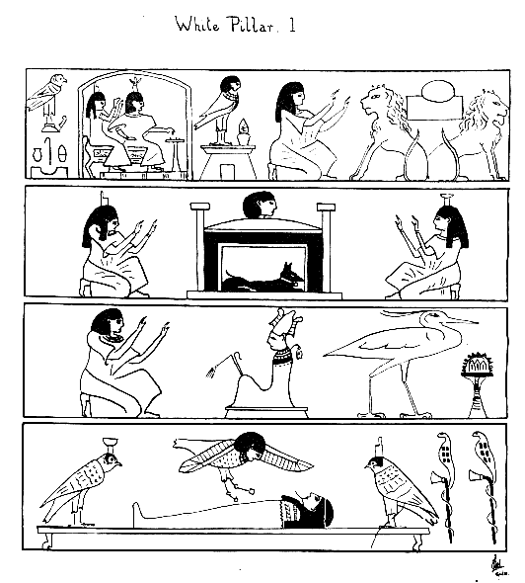
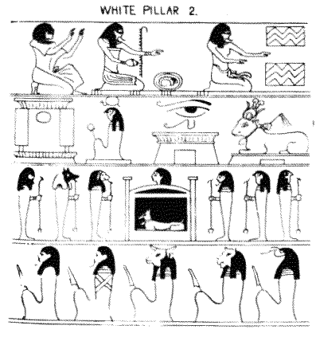
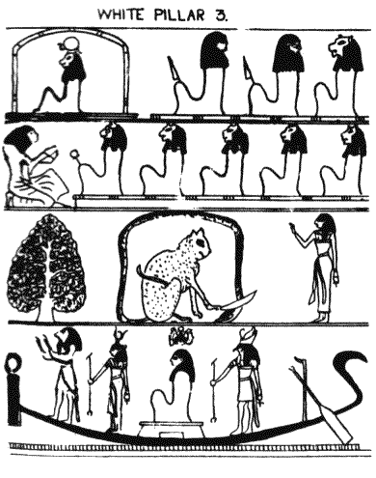
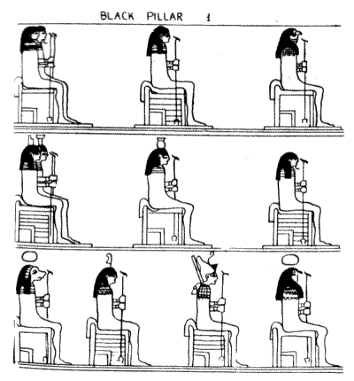
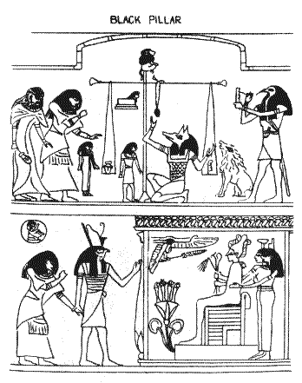
The black square bases represent Darkness and Matter wherein the Spirit, the Ruach Elohim, formulate the eternal pronunciation of the Ineffable name: that name which the Rabbins of old have said rusheth through the Universe; that name before which rolled back the darkness at the birth of the Morning of Time.
The flame-red triangular capitals which crown the summits of the Pillars represent the Triune Manifestation of the Spirit of Life, the 'three Mothers' of the Sepher Yetzirah, the three alchemical principles of Nature, the Sulphur, the Mercury and the Salt, and each Pillar is surmounted by its own Light-bearer, though veiled from the material world.
The Hieroglyphical figures upon the Pillars are taken from the vignettes of the 17th and 125th Chapters of the 'Ritual of the Dead' the Egyptian 'Per-M-Hru'. This celebrated and most ancient work is a collection of mystical hymns and addresses in the form of a species of ceremonial ritual for the use of the Soul after Death, to enable him to unite himself to the Body of Osiris the Redeemer, thenceforth in the Ritual is he no longer called the Soul but he is called the 'Osiris' of whom he is a member. 'I am the Vine, ye are the branches' said the Christ of the New Testament. 'I am a member of the Body of Osiris' said the purified and justified Soul. The Soul luminous and washed from sin in the uncreated and immortal light, united to Osiris and justified Son of God, such is the subject of the great Egyptian Ritual, purified by suffering, strengthened by opposition, Nor is the 'Ritual of the Dead' a work of comparatively recent times, for the great Egyptologists Birch and Bunsen, assert that its origin is anterior to Menes, and belongs probably to the Pre-Menite Dynasty of Abydos, between 3100 and 4500 bc and it implies that at that period tiie system of Osirian worship and mythology was already in actual existence.
Of all the Chapters in the Per-M-Hru, the 17th is one of the oldest as shown by its gloss and scholia; and it is the symbols of this chapter and the 125th which form the designs of the Pillars before you. At the base of each rises the lotus symbolic of new life, regeneration and metempsychosis. In the papyri which have the hieroglyphical text of this chapter a group of red hieroglyphs occurs at intervals, the literal translation of which is the 'explanation'. After these groups comes a short Commentary or gloss on the preceding and more ancient text.
According to the pre-cited authorities this gloss was mixed up with the text as early as 2250 bc at a period long anterior to the era of Joseph and to that of the Trojan War, and the circumstances of its possessing a written Commentary, even at this early date shows that much greater antiquity of the actual text. The especial title of the 17th chapter is 'The Book of the Egyptian Faith' and its subject is a sort of hymn of the Osirified Soul, which may be partially and succintly reproduced as follows:

The Words of the Departed Spirit, Osiris — Son of God
I am Temu, the Setting Sun — I am the only Being in the Firmament.
I am Ra, the Rising Sun, I have passed from the Gate of Death unto life.
The Sun's power beginneth again, after he hath set he riseth again. (So doth the justified Spirit of Man)
I am the Great God, begotten of himself. I can never be turned back by the Elementary Powers: I am the Morning, I know the Gate: (I ever rise again into Existence; I know the Pathway through Death unto Life.)
The Father of the Spirit, the Eternal Soul of the Sun, he hath examined and he hath proved me; he hath found that I fought on Earth the battle of the Good Gods — as he, my Father, Lord of the Invisible World, hath ordered me to do.
I know the Great God who existeth in the Invisible. I am the Great Phoenix which is in Annu, the Former of my Life and my Being am I.

The symbols on the columns, beginning at the top of the one with black figures on a white ground, are mystical representations of the various paragraphs of the 17th chapter. They show: The symbols of Temu, the Setting Sun, the Past and the Future. The Adoration of Temu in the West. The Abode of the West shown by the Jackal of Anubis in a shrine with Isis and Nephthys adoring. The Adoration of Osiris. The Phoenix or Bennu. The reformation of the departed spirit shown by the soul descending to the body on the bier, in the form of a human headed bird, Khem of dual manifestation, shown by the birds on either side of the prostrate mummy. So the purified soul passes ever onward and upward, and still uses its mystical hymn. It reaches the pools of the two Truths, shown by the two quadrangular figures; it passes through Anrutf, the Gate of the North, and through the Gate of Tajeser, and it saith to the mystical Guardians 'Give me your strength, for I am made even as ye'. Then comes the Mystical Eye of Osiris representing the orb of the Sun, and the Cow, symbolic of the Great Water, the Blue Firmament of Heaven. Next the adoration of the Lords of Truth behind the Northern Heaven. 'Hail unto ye, ye Lords of Truth, ye Chiefs behind Osiris! ye followers of her whose peace is sure.' Then the soul arises at the mystic pool of Persea Trees, wherein is Horus, symbolised by the great Cat, who slays the evil serpent, Apophis. Last of the symbols of the 17th chapter is the adoration of the Creator in his Bark, and the uniting of the purified Soul with its maker.
The 125th chapter is called The Hall of the Two Truths, and of separating a person from his sins when he has been made to see the faces of the Gods' It opens with a solemn adoration of the Lords of Truth and the Ceremony of passing by the forty-two Assessors of the Dead, represented by seated figures. Then comes the Weighing of the Soul, and the mystical naming of various parts of the Hall, the naming of which is insisted on by the various guardians, and is similar to the mystic circumambulation of the Neophyte in the Path of Darkness in the 0=0 when he has to name the Guardians of the Gates of the East and West. The figures on the Pillar represent the Soul introduced by the jackal-headed Anubis, the guide of the Dead, into the Hall of Truth. The Soul then watches the weighing of its actions in Earth life against a figure of Truth in the mystical scales of Ma by Anubis. Thoth, ibis-headed, records the judgement and the Devourer stands ready to seize if the soul has led an evil life.
Passing through this ordeal, the soul is then introduced into the presence of Osiris by Horus. Osiris sits in his shrine upon a throne, with the Crook and Scourge, symbols of mercy and severity, in his hands; behind him are Isis and Nephthys, the Goddesses of Nature and Perfection, and before him are the four Genii of the Dead, upon the Lotus Flower, the emblem of the metempsychosis. Thus the whole of the symbols upon the Pillars represent the advance and purification of the Soul, and its uniting with Osiris the Redeemer in that Golden Dawn of an infinite Light, wherein the Soul is transfigured, knows all and can do all, for it has become joined unto Eternal God in the veritable:

'Khabs-am Pekht
Konx om Pax
Light in Extension'

[From a manuscript transcript by W.E.H. Humphreys (Gnothi Seauton) dated March 1900.]

